Job Title: | Procurement Business Partner
Department: | Procurement
Reports to: | Principal Procurement Business Partner
Direct Reports: | None
Location: | Activity Based on Site
Contract Type: | Permanent
Grade: | CA5

Main purpose of the job

Provide a comprehensive, business-focused procurement and commercial service, ensuring that best value for money is achieved.

Responsibilities

Specific
Procurement
- Act as the procurement expert and adviser for the business, building and maintaining effective relationships with business management and operational teams to influence procurement strategy and decision-making.
- Lead multi-disciplinary teams to deliver effective contracts and design new commercial arrangements that reflect business requirements and risks.
- Manage the negotiation, planning and placement of contracts.
- Contribute to the development of the procurement strategy, working with colleagues, suppliers and other stakeholders to improve value creation and deliver increased benefits.

Stakeholder Relationship Management
- Manage suppliers and contracts effectively to sustain value throughout the life of each contract.
- Apply category management principles where appropriate, including researching and understanding the markets in which the business operates.
- Engage appropriate internal and external stakeholders to gather information and insight that supports the development of strategic procurement activity.
- Develop supplier relationship management strategies to improve performance, increase market knowledge, establish a structured supplier engagement programme and benchmark performance.

Procurement Administration
- Ensure compliance with relevant UK procurement legislation, government requirements and Authority policy.
- Ensure that appropriate commercial contract documentation and conditions of contract are applied to protect the Authority.
- Manage the procedures required to obtain procurement approvals and authorisations, ensuring expenditure is properly directed and in accordance with Authority policies.
- Provide and deliver training on procurement procedures and policies.
- Produce management information and reports.

General
- Act in line with the behaviours and values of the organisation.
- Manage your own performance to be accountable for meeting individual, team and corporate objectives.
- Act in accordance with the Scheme of Delegation and ensure propriety and regularity in the handling of public funds.
- Actively demonstrate the Mining Remediation Authority’s customer service standards expected of your role.
- Follow and contribute to the improvement of operational and team processes and procedures.
- Assist with the preparation and delivery of the team’s objectives, budgets and financial records.
- Identify opportunities and implement change leading to team development, system. improvement and ensuring good value for money.
- Maintain and develop positive stakeholder relationships in order to promote the Authority and assist it to meet its objectives.
- Support research and development projects.
- Ensure that the Authority’s statutory responsibilities are effectively discharged.
- Carry out any further reasonable requests from your line manager.
Values in Action
We expect all our colleagues to embody our core values and behaviours in their daily work.

Trusted
- We act with integrity
- We’re open and transparent
- We deliver on our commitments

Inclusive
- We promote a culture of mutual respect
- We recognise that our differences make us stronger
- We work with others to achieve our vision

Progressive
- We’re open minded and innovative
- We recognise that the past can help us shape the future
- We listen and learn

Our Values in Action framework outlines important behavioural indicators that help us demonstrate our values through our work together.

Hybrid Working Model
This role sits within our Hybrid Working Model. The designated hybrid arrangement for this post is outlined under “Location” on page 1 of this Job Description and reflects the requirements of the role and the organisation. Hybrid working arrangements may be reviewed and adjusted if business needs change.

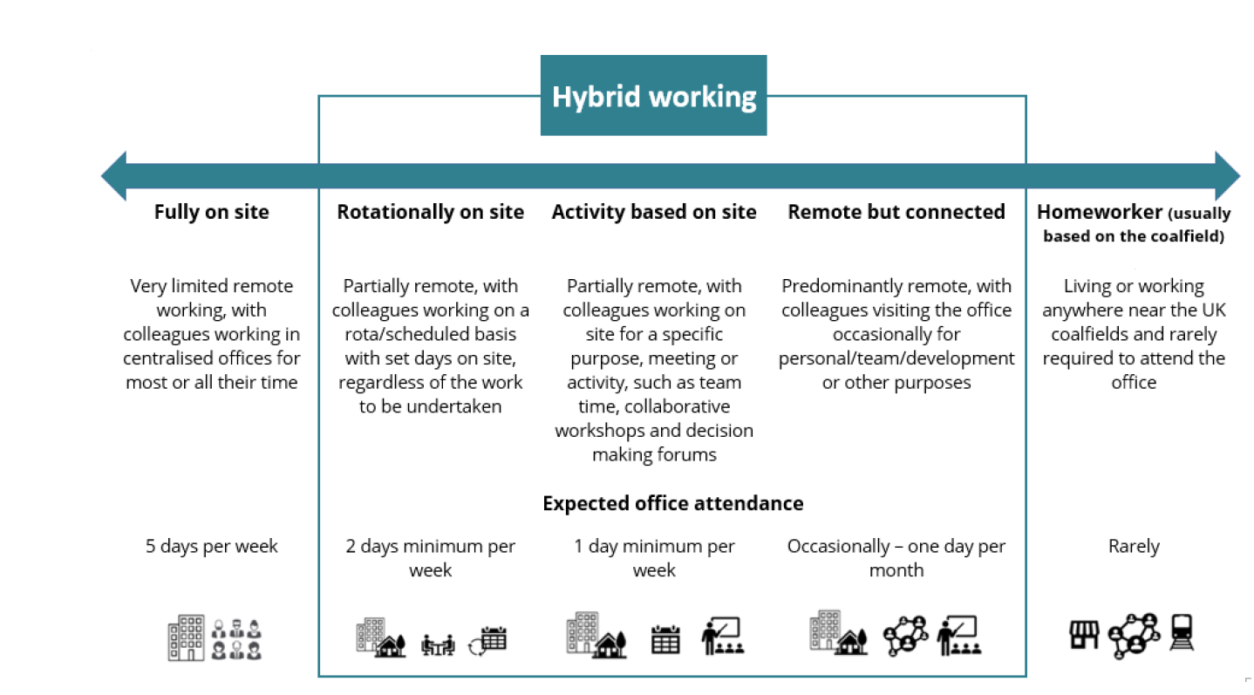

Person specification

Job Title: Procurement Business Partner |  |  | Department: Procurement
 | Essential |  | Desirable
Qualifications and Training | CIPS qualified, working towards CIPS, or able to demonstrate equivalent procurement and commercial experience.
Experience and Knowledge | Relevant procurement and commercial experience, including managing multiple procurement projects.  Good knowledge of UK public procurement legislation, including the Procurement Act 2023, transparency requirements and organisational governance.  Knowledge of procurement best practice across the procurement lifecycle, including evaluation, award and contract management.  Able to apply procurement principles including value for money, transparency, integrity and equal treatment.  Good negotiation, stakeholder management and commercial decision-making skills. |  | Experience gained within a regulated public sector procurement environment, including use of frameworks, competitive tendering procedures and procurement documentation.
Skills and Abilities | Able to work independently, manage competing priorities and deliver to deadlines.  Able to understand business needs, market conditions and commercial risks.  Able to engage effectively with stakeholders and support value-for-money outcomes.  Able to produce clear, accurate and auditable procurement records.  Able to apply procurement legislation and policy proportionately.
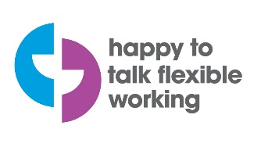 |  |  |  | 

