Job Title: | Health, Safety Wellbeing & Facilities Management Business Administration Apprentice
Department: | Health, Safety Wellbeing & Facilities
Reports to: | Principal Health, Safety & Wellbeing Manager
Direct Reports: | None
Location: | Activity Based On Site
Contract Type: | Permanent
Grade: | CA3

Main purpose of the job

To provide administrative and operational support to the Health, Safety & Wellbeing (HSW) team and Facilities Management (FM) team, contributing to the effective delivery of HSW&FM systems, initiatives and compliance activities across the organisation.

The role supports legal and regulatory compliance, promotes a positive safety and wellbeing culture and workplace environment and assists in maintaining safe systems of work across operational and office-based environments. It is designed to provide structured, hands-on experience aligned to a recognised Level 3 apprenticeship.

Responsibilities

Specific
- Support the coordination and administration of HSW and FM activities, programmes and improvement initiatives
- Assist in maintaining accurate HSW and FM records, including incident reports, risk assessments, inspections, maintenance logs and audit documentation
- Assist in preparing HSW reports, metrics and dashboards to support decision making
- Coordinate meetings, training sessions, wellbeing campaigns and facilities related activities, including logistics, communications and materials
- Support the development and delivery of internal communications, guidance and awareness campaigns that promote safe behaviours and effective use of workplace facilities
- Participate in workplace inspections and site visits, where appropriate, to provide admin support and build up knowledge
- Assist in monitoring contractor performance and compliance with HSW and organisational standards
- Identify opportunities to improve HSW and FM systems and processes
- Work collaboratively with operational teams, project managers, tenants and external suppliers to support safe and efficient delivery of services
- Undertake apprenticeship training and development activities to build knowledge, skills and professional competence across both HSW and FM disciplines

General
- Act in line with the behaviours and values of the organisation.
- Manage your own performance to be accountable for meeting individual, team and corporate objectives.
- Act in accordance with the Scheme of Delegation and ensure propriety and regularity in the handling of public funds.
- Actively demonstrate the Mining Remediation Authority’s customer service standards expected of your role.
- Follow and contribute to the improvement of operational and team processes and procedures.
- Assist with the preparation and delivery of the team’s objectives, budgets and financial records.
- Identify opportunities and implement change leading to team development, system. improvement and ensuring good value for money.
- Maintain and develop positive stakeholder relationships in order to promote the Authority and assist it to meet its objectives.
- Support research and development projects.
- Ensure that the Authority’s statutory responsibilities are effectively discharged.
- Carry out any further reasonable requests from your line manager.

Values in Action
We expect all our colleagues to embody our core values and behaviours in their daily work.
Trusted
- We act with integrity
- We’re open and transparent
- We deliver on our commitments
Inclusive
- We promote a culture of mutual respect
- We recognise that our differences make us stronger
- We work with others to achieve our vision
Progressive
- We’re open minded and innovative
- We recognise that the past can help us shape the future
- We listen and learn
Our Values in Action framework outlines important behavioural indicators which help us demonstrate our values through our work together.
Hybrid Working Model
This role sits within our Hybrid Working Model. The designated hybrid arrangement for this post is outlined under “Location” on page 1 of this Job Description and reflects the requirements of the role and the organisation. Hybrid working arrangements may be reviewed and adjusted if business needs change.
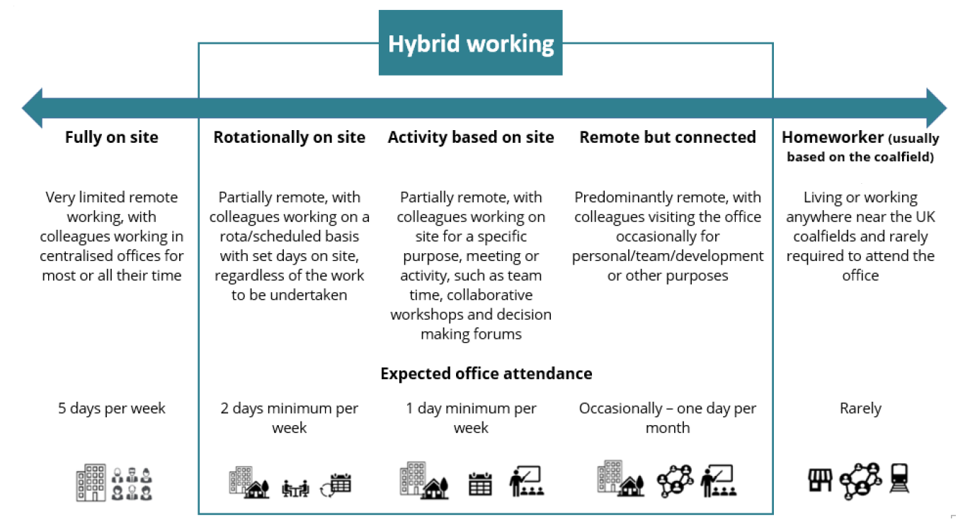

Person specification

Job Title: | Health, Safety & Wellbeing Apprentice |  | Department: |  | Health, Safety & Wellbeing
 | Essential |  | Desirable
Qualifications and Training | - GCSEs (or equivalent), including Maths and English  - Commitment to continuous learning and professional development |  | - Willing to work towards a Level 3 qualification in Health, Safety and Wellbeing or Facilities Management
Experience and Knowledge | - Demonstrate an interest in health, safety and wellbeing and/or facilities management  - Experience using Microsoft Office applications (word, excel, outlook) |  | - Awareness of health and safety legislation or principles  - Awareness of facilities management principles and compliance (maintenance, contractors, statutory compliance, fire safety)  - Experience in a team based or customer facing environment  - Knowledge of data protection and confidentiality
Skills and Abilities | - Strong organisational skills with attention to detail  - Effective written and verbal communication skills  - Resourceful, task focused, able to problem solve and prioritise to meet deadlines  - Good time management skills  - Positive team worker with the ability to maintain confidentiality  - Ability to work at pace and with flexibility  - Enthusiastic, proactive and motivated to learn |  | - Ability to support report writing and basis data analysis  - Ability to manage multiple tasks and work under pressure  - Problem solving skills and use of initiative
Other | - Willingness to promote a strong health, safety and wellbeing culture  - Commitment to equality, diversity and inclusion
 |  |  |  | 

