Job Title: | Customer Strategy and Support Project Lead
Department: | Customer Support and Services
Reports to: | Senior Customer Service Manager
Direct Reports: | None
Location: | Activity Based On Site
Contract Type: | Permanent
Grade: | CA4

Main purpose of the job

The Customer Strategy & Support Project Lead supports the delivery of the customer plan by coordinating the Customer Delivery Group, monitoring progress and helping maintain momentum across customer-focused initiatives. The role ensures actions are recorded, tracked, and kept on schedule, escalating issues to the Senior Customer Service Manager where appropriate.
They also play a key role in coordinating the planning and delivery of the customer survey, ensuring feedback is reviewed, analysed and fed into ongoing improvements. The role supports wider departmental work, contributing to operational and strategic projects as required.

Responsibilities

Specific

Customer Delivery Group Coordination
- Coordinate and support the Customer Delivery Group, ensuring actions aligned to the customer plan are clearly documented, prioritised and progressed.
- Maintain oversight of delivery against customer actions, tracking progress, dependencies, risks and mitigations.
- Identify emerging issues or slippage and escalate appropriately to ensure momentum is maintained.
- Prepare clear progress updates, summaries and insight reports for senior leaders and governance forums.

Customer Insight & Survey Delivery
- Take responsibility for the planning, coordination and delivery of the customer survey, working with relevant teams and the Customer Strategy and Support Coordinator to meet agreed timelines and engagement objectives.
- Collate, analyse and summarise customer feedback and survey results, identifying key themes, risks and opportunities.
- Translate insight into practical recommendations and ensure these are reflected in customer action plans and project activity.
- Support teams to understand and act on customer insight, embedding a customer-focused approach to improvement.

Project & Action Management
- Provide structured project coordination across customer initiatives, ensuring clarity of scope, ownership, milestones and outcomes.
- Maintain high-quality documentation including action logs, project plans, updates and decision records.
- Support the Customer Strategy and Support Coordinator with workshops, planning sessions and reviews to drive collaborative problem-solving and delivery.

Support to Wider Customer Projects
- Provide flexible support across Customer Support & Services on other customer-related projects and priorities as required.
- Act as a point of coordination between teams, helping to align activity, reduce duplication and improve ways of working.
- Support customer service leaders with preparation of reports, performance information, insight packs and improvement proposals.

Customer-Focused Culture
- Promote a strong customer-first mindset across projects and workstreams.
- Ensure customer impact and experience are considered in planning, decision-making and delivery.
- Contribute to continuous improvement activity across the department.

General
- Act in line with the behaviours and values of the organisation.
- Manage your own performance to be accountable for meeting individual, team and corporate objectives.
- Act in accordance with the Scheme of Delegation and ensure propriety and regularity in the handling of public funds.
- Actively demonstrate the Mining Remediation Authority’s customer service standards expected of your role.
- Follow and contribute to the improvement of operational and team processes and procedures.
- Assist with the preparation and delivery of the team’s objectives, budgets and financial records.
- Identify opportunities and implement change leading to team development, system. improvement and ensuring good value for money.
- Maintain and develop positive stakeholder relationships in order to promote the Authority and assist it to meet its objectives.
- Support research and development projects.
- Ensure that the Authority’s statutory responsibilities are effectively discharged.
- Carry out any further reasonable requests from your line manager.

Values in Action
We expect all our colleagues to embody our core values and behaviours in their daily work.
Trusted
- We act with integrity
- We’re open and transparent
- We deliver on our commitments
Inclusive
- We promote a culture of mutual respect
- We recognise that our differences make us stronger
- We work with others to achieve our vision
Progressive
- We’re open minded and innovative
- We recognise that the past can help us shape the future
- We listen and learn
Our Values in Action framework outlines important behavioural indicators which help us demonstrate our values through our work together.
Hybrid Working Model
This role sits within our Hybrid Working Model. The designated hybrid arrangement for this post is outlined under “Location” on page 1 of this Job Description and reflects the requirements of the role and the organisation. Hybrid working arrangements may be reviewed and adjusted if business needs change.
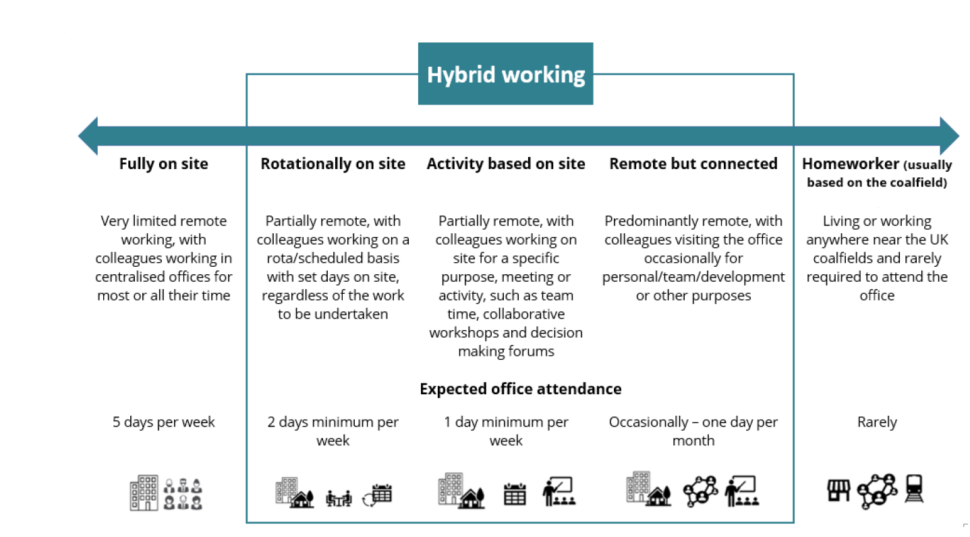

Person specification

Job Title: | Customer Strategy and Support Project Lead |  | Department: |  | Customer Support and Services
 | Essential |  | Desirable
Qualifications and Training | - Educated to degree level or equivalent relevant experience in a customer service, customer strategy, project coordination, public service or business-related field.  - Commitment to ongoing professional development relevant to customer strategy, service improvement or project delivery. |  | - A recognised project management or continuous improvement qualification  - A customer service or customer experience qualification.
Experience and Knowledge | - Experience managing multiple actions or projects.  - Experience working collaboratively across teams and building effective working relationships.  - Experience managing competing priorities, deadlines and workstreams in a fast‑paced environment.  - Experience translating customer insight, feedback or survey results into actions, improvements or recommendations.  - Experience preparing clear progress updates or reports for senior stakeholders, boards or governance groups.  - Experience working with risk, issues or escalation processes, identifying problems early and supporting resolution. |  | - Familiarity with survey delivery, action-tracking or reporting tools.  - Understanding of customer journey thinking or continuous improvement approaches.  - Experience supporting customer strategy, customer experience or service improvement activity.
Skills and Abilities | - Strong planning, organisational and coordination skills  - Confident communicator, able to present information clearly to a range of audiences  - Ability to analyse qualitative and quantitative customer feedback and translate it into clear insights.  - Ability to identify risks and escalate appropriately.
Other | - Flexibility to meet the requirements of the job.
 |  |  |  | 

