Job Title: | Procurement Assistant
Department: | Procurement
Reports to: | Zoë Heywood
Direct Reports: | None
Location: | Please select ONE of the following:  Rotationally on Site
Contract Type: | Please select ONE of the following:  Temporary
Grade: | CA3

Main purpose of the job

To train to become a procurement professional by obtaining the Level 3 Apprenticeship Standard for Procurement and Supply. To provide administrative support to the whole Procurement Team.

Responsibilities

Specific

To act in accordance with the Scheme of Delegation and ensure propriety and regularity in the handling of public funds;

To act in accordance with the behaviours and values of the organisation;

To learn how to effectively assess and manage risks;

Provide procurement support services to Business partners and their stakeholders across the procurement lifecycle as required

To assist with the administration of tender documentation and processes
Including but not limited to undertaking market research, drafting documents, publishing statutory notices, monitoring communication in the tendering portal, note-taking in evaluation meetings, compiling award letters, issuing contract documentation

To assist with the maintenance of the relevant contract databases and records.

Assist with ongoing management of framework agreements including updating of databases, internal documentation, and associated processes.

To attend meetings where required and action and required outcomes

To maintain and develop positive stakeholder relationships in order to promote the Authority and assist it to meet its objectives;

To learn how to support the Authority’s statutory responsibilities so they are effectively discharged;

To learn and use various digital applications with confidence

General
- Act in line with the behaviours and values of the organisation.
- Manage your own performance to be accountable for meeting individual, team and corporate objectives.
- Act in accordance with the Scheme of Delegation and ensure propriety and regularity in the handling of public funds.
- Actively demonstrate the Mining Remediation Authority’s customer service standards expected of your role.
- Follow and contribute to the improvement of operational and team processes and procedures.
- Assist with the preparation and delivery of the team’s objectives, budgets and financial records.
- Identify opportunities and implement change leading to team development, system. improvement and ensuring good value for money.
- Maintain and develop positive stakeholder relationships in order to promote the Authority and assist it to meet its objectives.
- Support research and development projects.
- Ensure that the Authority’s statutory responsibilities are effectively discharged.
- Carry out any further reasonable requests from your line manager.

Values in Action
We expect all our colleagues to embody our core values and behaviours in their daily work.
Trusted
- We act with integrity
- We’re open and transparent
- We deliver on our commitments
Inclusive
- We promote a culture of mutual respect
- We recognise that our differences make us stronger
- We work with others to achieve our vision
Progressive
- We’re open minded and innovative
- We recognise that the past can help us shape the future
- We listen and learn
Our Values in Action framework outlines important behavioural indicators which help us demonstrate our values through our work together.
Hybrid Working Model
This role sits within our Hybrid Working Model. The designated hybrid arrangement for this post is outlined under “Location” on page 1 of this Job Description and reflects the requirements of the role and the organisation. Hybrid working arrangements may be reviewed and adjusted if business needs change.
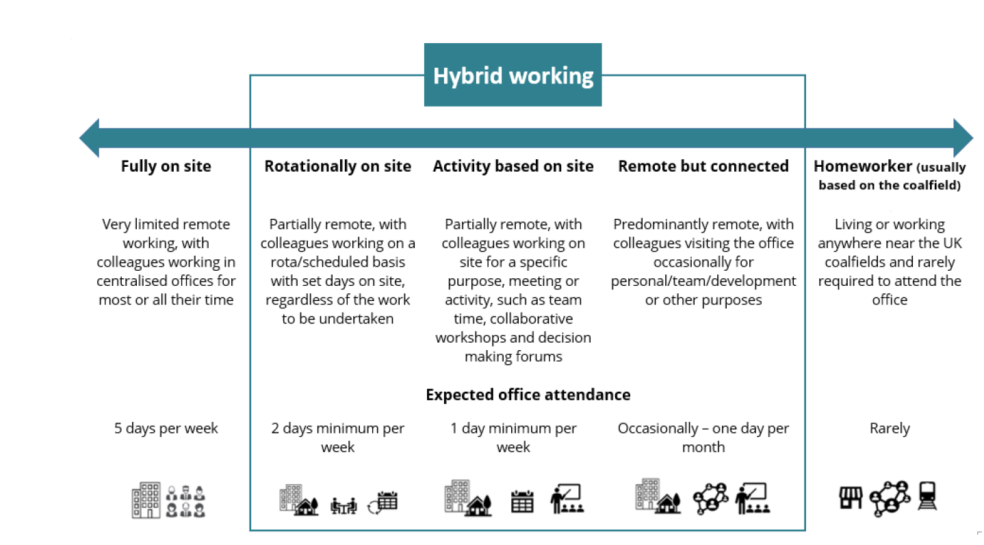

Person specification

Job Title: | Procurement Assistant |  | Department: |  | Procurement
 | Essential |  | Desirable
Qualifications and Training | - Level 2 (or equivalent) English and Mathematics |  | - A-level
Experience and Knowledge | - Experience or understanding of, or the use of Microsoft Office: Word, Excel and PowerPoint.  - Self-discipline in a workplace or education environment to show the achievement of goals.
Skills and Abilities | - Ability to study in own time to complete professional qualifications.  - Ability to build relationships with a diverse range of people.  - Self-motivation
Other | - Honest, reliable, good timekeeping and understanding of the need for confidentiality  - Communication skills (written and oral) and capable of dealing with staff of all levels.  - Prepared to work as part of a team using practicality and innovation to resolve problems.  - Organisational skills including calendar management and the ability to meet tight deadlines
 |  |  |  | 

