Job Title: Records Manager
Department: Finance, Digital, Business Planning and Legal
Reports to: Head of Legal and Records
Direct Reports: 2 x Records Officers
Location: Rotationally On Site
Contract Type: Fixed Term Contract
Grade: CA5

Main purpose of the job

To implement, champion and embed the Mining Remediation Authority’s Information and Records Policy to ensure the Mining Remediation Authority operates procedures and practices that:
- Manage records to the standards necessary to satisfy the needs and demands of the business and its’ stakeholders
- Conform to applicable legislative requirements including, but not limited to, the Public Records Act, the Freedom of Information Act and the Data Protection Act
- Conform to the National Archives (TNA) guidelines for records management and the standards required for Non-Departmental Public Bodies
- To fulfil the role of Departmental Records Officer (DRO) for the Mining Remediation Authority in its’ relationship with the National Archives.
- To manage in conjunction with other departments all aspects of the Mining Remediation Authority’s relationship with the supplier of the current and future electronic documents and records management system.

Responsibilities

Specific

- To lead on ensuring there is a culture of excellent records management practices across the organisation, for both electronic and paper records,
- To ensure the Authority’s Electronic Documents and Records Management System is operated and maintained to the required standards for the registration, management, review and disposal of electronic and paper records.
- To lead and implement the review of EDRMS specifications and produce relevant documentation to ensure the successful delivery of business-critical systems that work to the Authority’s requirements.
- To have excellent customer service skills.
- To have knowledge and experience in responding to Freedom of Information Act 2000 and Environmental Information Regulations requests. To take account of the Codes of Practice issued in accordance with sections 45 and 46 of the Freedom of Information Act, which respectively set out good practice in handling requests for information and records management.
- Undertake Internal Reviews and manage complaints made to ICO.
- Manage with the team Access to Information Rights, Subject Access Requests (SARs).
- Assist with Data Protection Impact Assessments (DPIAs) and investigating data breaches.
- To manage all aspects of the Authority’s records stores and deliver a safe, effective and efficient records management service to authorised users.
- To consider efficiency savings to enable the business to work smarter with the management of information and records.
- To review and revise the Authority’s filing systems, both manual and, as appropriate, electronic.
- To instigate first review of records i.e. appraising the records against the disposal schedule for retention/disposal.
- To liaise with DESNZ/DSIT Knowledge Information Management (KIM) community and other arm’s length bodies.
- Through Business and Project planning, contribute to other Authority projects on all matters affecting records management.

The National Archives
- To administer all records owned by the Authority in accordance with the requirements of the Public Records Act 1958 and Section 46 of FOIA.
- To prepare disposal schedules for records and agree these with the National Archives, DESNZ and action the review decisions contained therein.
- To meet public sector targets set by government in discussion with and monitored by the National Archives.

Policy/Standards Formulation and Compliance
- To provide advice on records management policy matters and ensure implementation through appropriate governance arrangements approval where required.
- To make accessible the Records Management Policy to all authorised users of the Authority’s records. Provide tailored guides for each department of what and where to store information.
- To prepare and keep updated Information and Records Risk Management issues on the Team and Corporate register in conjunction with the Authority’s designated Risk Manager and SIRO.
- To keep updated the procedure for responding to requests under the Freedom of Information Act 2000, EIR or SARs, working with the Data Protection Officer.
- To ensure appropriate information security measures are in place and continuously applied to prevent unauthorised access to the Authority’s digital and physical records.
- To contribute to project work affecting information and records management.
- To prepare and manage the Records Management Department budget within agreed limits.
- To fulfil all aspects required as manager of EDRMS including, but is not limited to:
  - Compilation and presentation of reports to Head of Department
  - Close liaison with ICT Service Delivery Manager on EDRMS service delivery standards and problem management
  - Liaison with the EDRMS Supplier on all aspects of the EDRMS service including Service Level Agreements and problem management
  - Progress with further EDRMS objectives in line with business requirements
- To deal with general and detailed enquiries from DESNZ, Consultants and other professionals e.g. Legal, the National Archives, County Records Offices, Iron Mountain and members of the public and supply information to authorised persons taking full account of applicable legislation including the Freedom of Information Act 2000.
- To contribute to the Business Continuity Plan with the aim of ensuring that a Records Management service can continue in the event that the Plan is invoked.
- To identify, record and manage the Health, Safety and Wellbeing risks associated with the Records Management function.
- To support the Executive and line managers by locating and providing information to facilitate the carrying out of the Authority’s statutory duties.

General

- Act in line with the behaviours and values of the organisation
- Manage your own performance to be accountable for meeting individual, team and corporate objectives
- Act in accordance with the Scheme of Delegation and ensure propriety and regularity in the handling of public funds
- Actively demonstrate the Mining Remediation Authority’s customer service standards expected of your role
- Follow and contribute to the improvement of operational and team processes and procedures
- Assist with the preparation and delivery of the team’s objectives, budgets and financial records
- Identify opportunities and implement change leading to team development, system improvement and ensuring good value for money
- Maintain and develop positive stakeholder relationships in order to promote the Authority and assist it to meet its objectives
- Support research and development projects
- Ensure that the Authority’s statutory responsibilities are effectively discharged
- Carry out any further reasonable requests from your line manager

Values in Action
We expect all our colleagues to embody our core values and behaviours in their daily work.
Trusted
- We act with integrity
- We’re open and transparent
- We deliver on our commitments
Inclusive
- We promote a culture of mutual respect
- We recognise that our differences make us stronger
- We work with others to achieve our vision
Progressive
- We’re open minded and innovative
- We recognise that the past can help us shape the future
- We listen and learn
Hybrid Working Model
This role sits within our Hybrid Working Model. The designated hybrid arrangement for this post is outlined under “Location” on page 1 of this Job Description and reflects the requirements of the role and the organisation. Hybrid working arrangements may be reviewed and adjusted if business needs change.
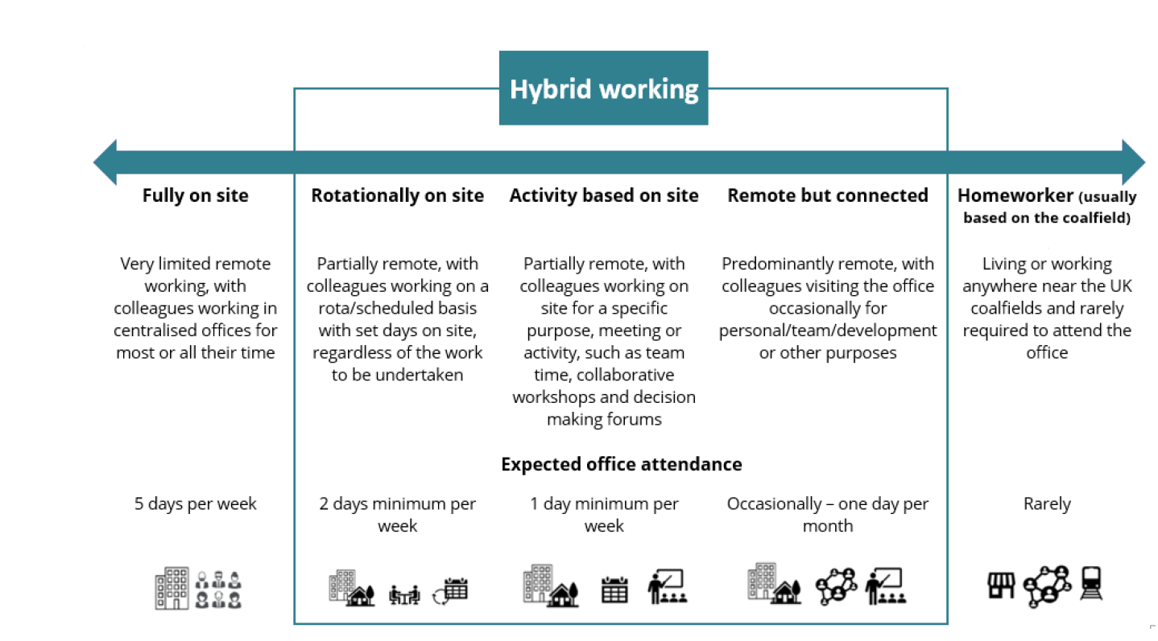

Person specification

Job Title: Records Manager Department: Finance, Digital, Business Planning and Legal

 | Essential | Desirable
Qualifications and Training | - Working towards or hold professional qualifications in archives and records management | - Degree or equivalent  - Knowledge Information Management KIM/GKIM practitioner  - Membership of a relevant professional body
Experience and Knowledge | - Experience in managing both paper and electronic records to the required standard  - Experience of the statutory framework for the management of public records  - Experience of managing customer/stakeholder relationships and engagement  - Experience of budgetary control  - Experience of the Freedom of Information Act, Environmental Information Regulations and UK GDPR Data Protection Act 2018 | - Knowledge of copyright and intellectual property rights
Skills and Abilities | - Ability to work both independently and as part of a team, be motivational, as well as being self-motivated  - Strong discipline for achieving targets and deadlines  - Accuracy with a good eye for detail  - Excellent communication and relationship skills working across the organisation  - Able to influence other parties to achieve the required goals  - Flexibility relative to on-going business needs | - Good IT skills and knowledge of Microsoft Office 365, Teams and SharePoint  - Good organisational skills and an ability to design file plans

