Job Title: Construction Health, Safety, Wellbeing and Environment Advisor
Department: Health, Safety and Wellbeing
Reports to: Principal Construction Health, Safety, Wellbeing and Environment Manager
Direct Reports: None
Location: Activity-based onsite
Contract Type: Full time
Grade: CA5

Main purpose of the job

- Your primary responsibility will be supporting the abandoned metal mines programmes that we deliver on behalf of Defra (the Water and Abandoned Metal Mines programme or ‘WAMM’) and Welsh Government (the Wales Metal mines Programme or ‘WMMP’).
- The Programmes develop, plan and deliver pollution mitigation and environmental improvement projects across the portfolio of abandoned metal mine sites in Wales and England; being delivered in partnership with Natural Resources Wales (the WMMP), and the Environment Agency (WAMM) requiring truly collaborative working.
- The Programmes includes a variety of remedial interventions, including surface water and spoil heap management, and mine water treatment schemes, often trialling and implementing novel and emerging technologies.
- You will support project and project managers to proactively identify, manage and report health and safety risks, issues and incidents during the development, design and construction of legacy metal mining remedial assets and associated infrastructure.
- You will support the Mining Remediation Authority in fulfilling its statutory health, safety and wellbeing (HSW) obligations across construction and civil engineering projects, while driving continual improvement in HSW performance and culture.
- This may also include projects associated with the remediation of mining-related surface hazards and subsidence damage, the construction, operation and maintenance of mine water treatment schemes, the development of mine water heat recovery schemes, desalination schemes, and other innovative environmental engineering solutions.

Responsibilities

Specific

- Working with project and programme managers, to ensure compliance of projects with legal duties (including those of Client, Designer and Principal Designer) under the Construction (Design and Management) Regulations 2015 (CDM 2015). This includes identifying and supporting the management of risks, issues and incidents on behalf of project managers and the monitoring and reporting of those on behalf of programme managers.
- To provide expert technical knowledge, reviewing and challenging outputs from internal and external teams, including designs, concepts and reports, and to be proactive in identifying risks during all stages of the project lifecycle including the development, design and construction of physical assets, to ensure that projects comply with all aspects of Health and Safety relating to infrastructure / asset development, design, construction, and maintenance.
- To analyse H&S needs relating to the project delivery teams and develop/design, arrange and participate in in-house training and external training where required,
- To monitor general HSW legislative requirements and in particular those under CDM 2015 across all of the Authority’s construction projects under your areas of responsibility, to ensure compliance is achieved and industry best practice is strived for.
- To assist in delivering the Authority’s Sustainability and Health, Safety and Wellbeing Plans, contributing to achieving the associated objective
- Participate in project meetings throughout the full project lifecycle and collaborate with key stakeholders to provide HSW advice, guidance and support
- Support the development of Pre-Construction Information, leading on the coordination and production
- Reviewing Construction Phase Plans and RAMS prior to commencement of works, identifying information gaps and working with Contractors and internal teams where applicable to ensure the suitability and adequacy of those plans.
- Identify opportunities for improvements to HSW processes and procedures under your areas of responsibility, leading on improvement initiatives as agreed with programme managers.
- To monitor and communicate HSW lessons learnt from within the Authority and from external sources, where those lessons help to improve HSW performance and reduce risks, on projects and programmes
- Reviewing and providing advice, assurance and support on the preparation of Health and Safety Files, supporting those responsible for its compilation to ensure compliance with legal and Authority requirements
- Undertake site visits (as per operational requirements, which could be up to 8 site visits a month), HSW inspections and desktop audits to monitor compliance with safety, health, wellbeing and environmental legislation, striving to meet leading industry practice. This will include pre-planned overnight stays where necessary.
- Support project managers to ensure construction sites are established and compliant with all current regulations and standards including suitable welfare provisions
- Where standards are unacceptable or risks are identified, advise those responsible to take appropriate action, including stopping works where necessary; and where material breaches of health and safety law or significant risks exist, instruct works to cease. Support all parties in identifying, developing and implementing the actions required for safe recommencement.
- Supporting project managers and working with Contractors to develop proposals for corrective or preventive measures and investigate or arrange for all accidents and near-misses to be investigated, preparing report of findings where necessary, including recommendations to prevent recurrence and implement approved course of action and supporting contract related processes.
- Advise project teams on the actions required when projects do not meet the Authority’s standards, leading the engagement with Contractors to ensure, where necessary, that remedial measures are identified and actioned
- Act as a role model for health, safety, wellbeing and environmental management, and promote a positive culture across the business
- Liaise with external regulatory and government bodies (e.g. HSE, DEFRA, EA, NRW) as required, ensuring all interactions are conducted professionally and in accordance with corporate confidentiality and integrity standards
- Promote the integration of sustainability considerations throughout all stages of construction projects, working with the Sustainability Team to provide advice to project teams and support alignment with sustainability objectives
- Lead or assist in the investigation of accidents and incidents and where required, the accurate completion and submission of RIDDOR reports
- Carry out such additional duties and responsibilities as may reasonably be required by the Authority from time to time

General
- Act in line with the behaviours and values of the organisation
- Manage your own performance to be accountable for meeting individual, team and corporate objectives
- Act in accordance with the Scheme of Delegation and ensure propriety and regularity in the handling of public funds
- Actively demonstrate the Mining Remediation Authority’s customer service standards expected of your role
- Follow and contribute to the improvement of operational and team processes and procedures
- Assist with the preparation and delivery of the team’s objectives, budgets and financial records
- Identify opportunities and implement change leading to team development, system improvement and ensuring good value for money
- Maintain and develop positive stakeholder relationships in order to promote the Authority and assist it to meet its objectives
- Support research and development projects
- Ensure that the Authority’s statutory responsibilities are effectively discharged
- Carry out any further reasonable requests from your line manager

Values in Action
We expect all our colleagues to embody our core values and behaviours in their daily work.
Trusted
- We act with integrity
- We’re open and transparent
- We deliver on our commitments

Inclusive
- We promote a culture of mutual respect
- We recognise that our differences make us stronger
- We work with others to achieve our vision

Progressive
- We’re open minded and innovative
- We recognise that the past can help us shape the future
- We listen and learn
Our Values in Action framework outlines important behavioural indicators which help us demonstrate our values through our work together.

Hybrid Working Model
This role sits within our Hybrid Working Model. The designated hybrid arrangement for this post is outlined under “Location” on page 1 of this Job Description and reflects the requirements of the role and the organisation. Hybrid working arrangements may be reviewed and adjusted if business needs change.
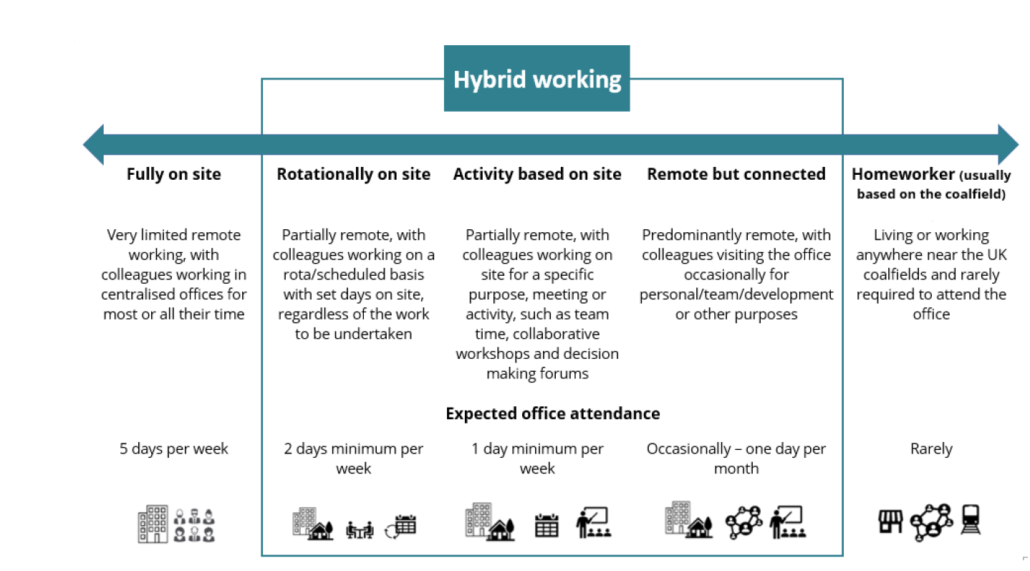

Person specification

Job Title: Construction HSW and Environment Advisor Department: Health, Safety and Wellbeing

 | Essential | Desirable
Qualifications and Training | - NEBOSH General Certificate or equivalent | - Level 6 qualification in health and safety or equivalent  - NEBOSH Construction Certificate or equivalent  - Degree or equivalent qualification in construction, engineering or related discipline  - ISEP or similar environmental certificate or diploma  - Membership of IOSH - minimum Technical grade  - An ongoing commitment to a ‘Continuing Professional Development’ programme
Experience and Knowledge | - In depth knowledge of construction Health, Safety, Wellbeing and Environmental legislation  - Working knowledge of engineering and design processes sufficient to identify foreseeable risks and associated control measures  - Comprehensive knowledge of the CDM Regulations, including the roles, duties, and interactions of Clients, Principal Designers, Principal Contractors, Contractors and Designers across the project lifecycle | - Experience of assisting the role of Client and/ or Principal Designer under the CDM Regulations (or previously as a CDM co-ordinator)  - Experience in managing or advising on Environmental issues on site  - Knowledge/ experience in any of the below areas:  - Temporary works  - Lifting operations  - Excavations / ground risk  - Utilities / buried services  - Work at height  - An understanding of ISO 45001and/ or ISO 45003
Skills and Abilities | - Ability to manage a diverse workload and ensure work is completed on time  - Strong communication skills, with the ability to clearly influence, challenge, and engage a range of stakeholders  - Experience with Audit/Site Inspections and Behavioural Discussions including the ability to positively influence and constructively challenge unsafe behaviours  - Able to work independently, with minimal supervision as well as collaborating effectively with multidisciplinary teams
Other

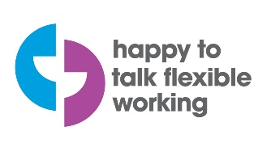 | 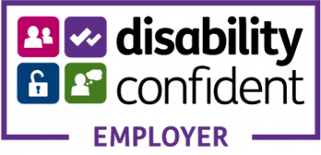 | 