Job Title: | Regional Project Manager - Scotland
Department: | Public Safety & Subsidence
Reports to: | Principal Project Manager
Direct Reports: | None
Location: | Homeworker
Contract Type: | Temporary
Grade: | CA5

Main purpose of the job

To administer a portfolio of coal mining related hazard, enquiry and subsidence projects in Scotland.
Role location: The role involves working in the former coal mining areas of Scotland, based at home with regular site visits and occasional overnight stays.

Responsibilities

Specific

- To ensure that your portfolio of projects is adequately progressed and resourced, and that your stakeholders are effectively managed.

- To implement project plans and priorities.

- To ensure adequate investigations are carried out to determine the Authority’s liability.

- To ensure that all projects and fieldworks are economically, efficiently and effectively managed and all statutory obligations are discharged.

- To act from time to time as Designer for the purposes of the CDM 2007 or subsequent regulations.

- To supervise contractors and consultants undertaking research, investigations and remediation. This includes the effective production and management of the current suite of NEC 4 contract documentation.

- To undertake field related tasks as required which may include the inspections of tips, properties, liability sites, undertaking monitoring and sampling.

- To compile evidence and submissions in respect of any claims that may be referred to arbitration/lands tribunal.

- To act as a public interface, representing the Authority and dealing with live enquiries from members of the public, and other relevant parties

- To be part of response team to deal with calls to the Authority’s emergency hazard line

General

- Act in line with the behaviours and values of the organisation.
- Manage your own performance to be accountable for meeting individual, team and corporate objectives.
- Act in accordance with the Scheme of Delegation and ensure propriety and regularity in the handling of public funds.
- Actively demonstrate the Mining Remediation Authority’s customer service standards expected of your role.
- Follow and contribute to the improvement of operational and team processes and procedures.
- Assist with the preparation and delivery of the team’s objectives, budgets and financial records.
- Identify opportunities and implement change leading to team development, system. improvement and ensuring good value for money.
- Maintain and develop positive stakeholder relationships in order to promote the Authority and assist it to meet its objectives.
- Support research and development projects.
- Ensure that the Authority’s statutory responsibilities are effectively discharged.
- Carry out any further reasonable requests from your line manager.

Values in Action

We expect all our colleagues to embody our core values and behaviours in their daily work.

Trusted
- We act with integrity
- We’re open and transparent
- We deliver on our commitments
Inclusive
- We promote a culture of mutual respect
- We recognise that our differences make us stronger
- We work with others to achieve our vision
Progressive
- We’re open minded and innovative
- We recognise that the past can help us shape the future
- We listen and learn
Our Values in Action framework outlines important behavioural indicators which help us demonstrate our values through our work together.

Hybrid Working Model
This role sits within our Hybrid Working Model. The designated hybrid arrangement for this post is outlined under “Location” on page 1 of this Job Description and reflects the requirements of the role and the organisation. Hybrid working arrangements may be reviewed and adjusted if business needs change.
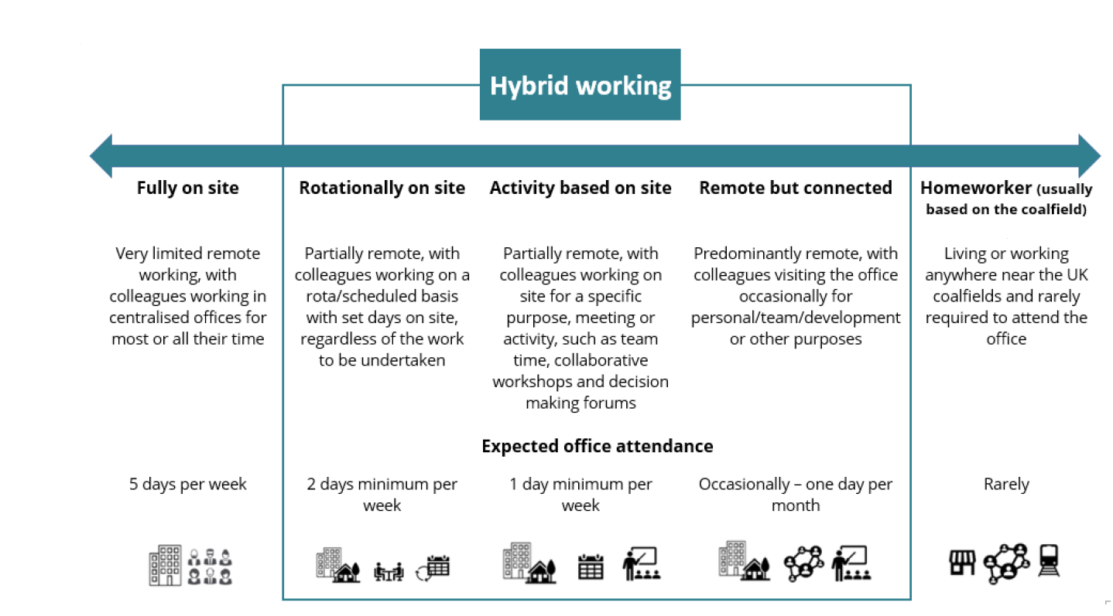

Person specification
Job Title: | Regional Project Manager - Scotland |  | Department: |  | Public Safety and Subsidence
 | Essential |  | Desirable
Qualifications and Training | No minimum qualification set, if the candidate can demonstrate relevant experience in project management, compliance, stakeholder & supplier management and assurance, construction or operational delivery within a regulated, public sector or comparable environment. |  | - HND / Degree or equivalent together with corporate membership of professional body (Surveying, Civil, Mining Engineering, Geology or appropriate discipline)
Experience and Knowledge | Some previous technical experience with a mining, surveying, geology or civil engineering background.  Experience of managing contractors |  | - Demonstrable technical experience with a mining, surveying, geology or civil engineering background with experience of subsidence claim and public safety hazard management.
Skills and Abilities | - Ability to undertake travelling to hazard/subsidence cases  - Excellent organisational skills  - Experience of Microsoft office  - Ability to prioritise tasks and use initiative  - Flexibility in working hours |  | - Working knowledge of Health, Safety and Environmental issues  - Knowledge of Subsidence Legislation  - Experience of interpreting mining related information.  - Knowledge of the technical management of mining legacy risks and hazards
Other | - Full UK Driving Licence |  | - Located within the existing coalfield areas of Scotland or can reach the Scotland Coalfields within a two-hour commute.
 |  |  |  | 

