Job Title: | Business Change Analyst (Fixed Term Contract to March 2028)
Department: | Corporate Programme Office
Reports to: | Business Change Manager
Direct Reports: | None
Location: | Activity based onsite
Contract Type: | Fixed Term Contract (22.5hrs / week)
Grade: | CA4

Main purpose of the job

To provide a proactive, professional and consistent level of support to the delivery of business change activity across the organisation, primarily in support of a large-scale ERP (Enterprise Resource Planning) programme.
The role will support the Business Change Manager in coordinating change activity, supporting stakeholder engagement, maintaining change plans, supporting the change champion network, and assisting with the development of communications and training materials to enable successful adoption of new systems and ways of working.
Where capacity allows, the postholder may also be required to support wider business change activity across other programmes or projects.

Responsibilities

Specific
- Assist with and contribute to the delivery and coordination of business change activity aligned to the ERP programme, working collaboratively with programme teams and business stakeholders
- Conduct and contribute to structured change impact assessments, including analysis of ‘as‑is’ and ‘to‑be’ processes, identifying impacts across user roles and proposing mitigating actions.
- Work closely with Business Analysts and programme teams to interpret process changes and ensure user impacts are understood and reflected in change activities.
- Maintain change documentation, including action logs, trackers, schedules and supporting plans, ensuring information remains accurate and is used to inform delivery decisions.
- Analyse and provide input into business readiness activity to support the delivery of programme objectives and expected benefits
- Assist with the planning and coordination of change initiatives to support adoption and minimise resistance
- Coordinate and facilitate the ongoing operation of the change champion network, including scheduling meetings, preparing agendas and following up actions.
- Contribute to the development and maintenance of change champion materials, toolkits, briefing packs and training guides
- Evaluate and create communications and materials that build awareness, understanding and readiness for change, aligned to recognised change methodologies (e.g. ADKAR), ensuring messages are tailored for different user groups/roles.
- Manage engagement activity across the programme, including workshops, briefings and working sessions, ensuring outputs and feedback are captured and used to inform change delivery
- Analyse feedback and insights from stakeholders throughout the lifecycle of the programme to identify themes, risks and recommended actions to inform the change approach.
- Maintain effective working relationships with colleagues across the organisation to support the successful delivery of change

General
- Act in line with the behaviours and values of the organisation.
- Manage your own performance to be accountable for meeting individual, team and corporate objectives.
- Act in accordance with the Scheme of Delegation and ensure propriety and regularity in the handling of public funds.
- Actively demonstrate the Mining Remediation Authority’s customer service standards expected of your role.
- Follow and contribute to the improvement of operational and team processes and procedures.
- Assist with the preparation and delivery of the team’s objectives, budgets and financial records.
- Identify opportunities and implement change leading to team development, system. improvement and ensuring good value for money.
- Maintain and develop positive stakeholder relationships in order to promote the Authority and assist it to meet its objectives.
- Support research and development projects.
- Ensure that the Authority’s statutory responsibilities are effectively discharged.
- Carry out any further reasonable requests from your line manager.

Values in Action
We expect all our colleagues to embody our core values and behaviours in their daily work.
Trusted
- We act with integrity
- We’re open and transparent
- We deliver on our commitments
Inclusive
- We promote a culture of mutual respect
- We recognise that our differences make us stronger
- We work with others to achieve our vision
Progressive
- We’re open minded and innovative
- We recognise that the past can help us shape the future
- We listen and learn
Our Values in Action framework outlines important behavioural indicators which help us demonstrate our values through our work together.
Hybrid Working Model
This role sits within our Hybrid Working Model. The designated hybrid arrangement for this post is outlined under “Location” on page 1 of this Job Description and reflects the requirements of the role and the organisation. Hybrid working arrangements may be reviewed and adjusted if business needs change.
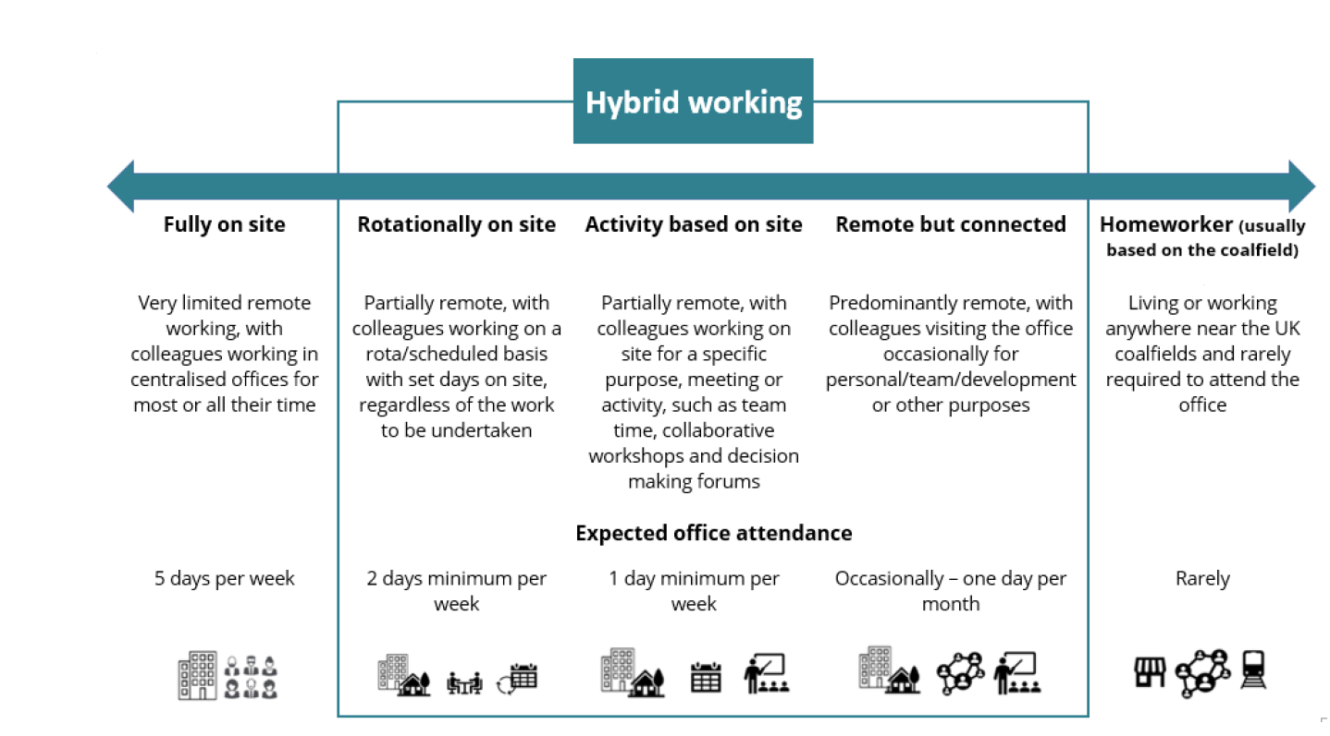

Person specification

Job Title: | Business Change Analyst |  | Department: |  | Corporate Programme Office
 | Essential |  | Desirable
Qualifications and Training | - Relevant experience supporting people-side of business change, project or programme delivery |  | - Awareness of business change or change management approaches (e.g. ADKAR, Kotter etc.)
Experience and Knowledge | - Experience supporting change, project or programme activity in a structured environment  - Experience coordinating workshops, meetings, actions, plans or engagement activity  - Experience drafting or contributing to communications or stakeholder engagement activity |  | - Experience supporting digital, systems or ERP‑related change initiatives
Skills and Abilities | - Strong written and verbal communication skills, with the ability to articulate messages to a variety of stakeholders  - Good organisational skills with strong attention to detail  - Good Interpersonal and ability to work collaboratively with a wide range of stakeholders  - Confident using Microsoft 365 tools (Teams, Outlook, SharePoint, Word, PowerPoint) |  | - Experience producing user‑focused guidance or internal communications
Other
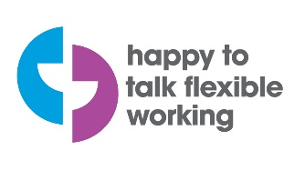 |  |  |  | 

