Job Title: | Environmental Scientist - Apprentice Hydrologist (Environmental Practitioner Degree Apprenticeship Level 6)
Department: | Technical Services
Reports to: | Hydrologist
Direct Reports: | None
Location: | Activity Based On Site
Contract Type: | Temporary Fixed Term Contract – 5 year apprenticeship
Grade: | CA3

Main purpose of the job

As an Apprentice Environmental Scientist, you will undertake the Environmental Practitioner Degree Apprenticeship (Level 6) with Keele University, combining academic study with practical, work-based experience in hydrology and hydrometry.

You will support the Hydrology team in the monitoring, analysis and management of surface water systems, flows and environmental data across the organisation’s operational sites, including mine water schemes. Through this, you will begin to develop an understanding of hydrological processes, flood risk, water quality and how water interacts with the environment.

Working alongside experienced colleagues, you will assist with the collection, management and interpretation of hydrological data, contributing to technical outputs and reporting across both operational and project-based work.

Over the course of the apprenticeship, you will progressively build the knowledge, skills and behaviours required to take increasing responsibility for hydrological monitoring, analysis and reporting, supporting the sustainable management of water systems and the protection of the environment.

Responsibilities

Responsibilities and development expectations for this role will be reviewed throughout the apprenticeship in line with the knowledge, skills and experience gained. The role will initially focus on supporting activities, as outlined below, with increasing responsibility and ownership of tasks as competence develops over the course of the programme.

Specific
- Demonstrate a keen interest in hydrology, environmental management and water systems.
- Take a proactive approach to academic and work-based learning through the Environmental Practitioner Degree Apprenticeship.
- Support the monitoring and collection of hydrological data including rainfall, river levels, flows and water quality, including working on projects which involve the design and installation of either new flow measurement structures or upgrade of existing sites.

- Assist in the organisation and analysis of hydrological data to support understanding of water systems and environmental risk. Including use of the Authorities AQUARIUS software to store, assess, edit, grade and graphically present monitoring data, with an emphasis on continual improvement of quality and timeliness of data entry and processing of that data.
- Support fieldwork activities, including site inspections, flow monitoring surveys and monitoring equipment installation and maintenance.
- Assist in the preparation of technical outputs including reports, data summaries and presentations.
- Develop an understanding of flood risk, drainage and catchment processes, for example, by undertaking flood risk work to determine impacts of proposed modifications within the catchment on flooding or using flow & chemistry data to determine the relative impacts of different pollution sources within a catchment.
- Work collaboratively with hydrologists and other specialists on environmental and water-related projects.
- Develop knowledge of relevant legislation, standards (e.g. MCERTS/ ISO standards for design of flow measurement structures) and organisational procedures.
- Progressively take ownership of defined tasks and outputs as competence develops.

General
- Act in line with the behaviours and values of the organisation.
- Manage your own performance to be accountable for meeting individual, team and corporate objectives.
- Act in accordance with the Scheme of Delegation and ensure propriety and regularity in the handling of public funds.
- Actively demonstrate the Mining Remediation Authority’s customer service standards expected of your role.
- Follow and contribute to the improvement of operational and team processes and procedures.
- Assist with the preparation and delivery of the team’s objectives, budgets and financial records.
- Identify opportunities and implement change leading to team development, system. improvement and ensuring good value for money.
- Maintain and develop positive stakeholder relationships in order to promote the Authority and assist it to meet its objectives.
- Support research and development projects.
- Ensure that the Authority’s statutory responsibilities are effectively discharged.
- Carry out any further reasonable requests from your line manager.

Values in Action
We expect all our colleagues to embody our core values and behaviours in their daily work.
Trusted
- We act with integrity
- We’re open and transparent
- We deliver on our commitments
Inclusive
- We promote a culture of mutual respect
- We recognise that our differences make us stronger
- We work with others to achieve our vision
Progressive
- We’re open minded and innovative
- We recognise that the past can help us shape the future
- We listen and learn
Our Values in Action framework outlines important behavioural indicators which help us demonstrate our values through our work together.
Hybrid Working Model
This role sits within our Hybrid Working Model. The designated hybrid arrangement for this post is outlined under “Location” on page 1 of this Job Description and reflects the requirements of the role and the organisation. Hybrid working arrangements may be reviewed and adjusted if business needs change.
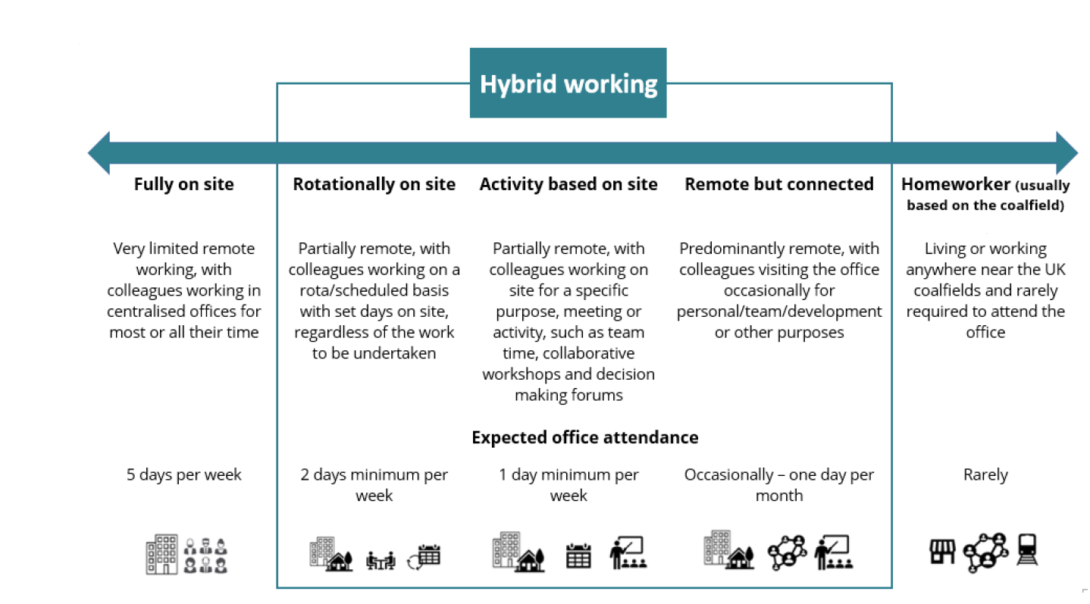

Person specification

Job Title: | Environmental Scientist - Apprentice Hydrologist (Environmental Practitioner Degree Apprenticeship Level 6) |  | Department: |  | Technical Services
 | Essential |  | Desirable
Qualifications and Training | Able to meet the entry requirements for Keele University’s Environmental Practitioner Degree Apprenticeship (Level 6), including:  - GCSE English and Maths at Grade 4 or above (or equivalent)  - And one of the following:  - 3 A Levels at Grade C or above (typically BBC or higher); or  - A relevant Level 3 qualification (e.g. A Levels, BTEC or equivalent) in geography, environmental science, science or a related subject; or  - Equivalent relevant experience in a related field  Applicants with substantial and relevant experience may be considered without formal qualifications, subject to assessment and approval by Keele University.  - Full UK driving licence |  | Relevant subjects such as geology, geography, environmental science, chemistry, physics, biology or mathematics
Experience and Knowledge | - A genuine interest in hydrology, environmental management and water systems  - An interest in surface water, rivers, drainage and how water interacts with the natural and built environment  - An awareness of the importance of health, safety and environmental standards in field and office-based work |  | - Any relevant work experience, volunteering, fieldwork or project work related to the environment, water or sustainability  - Awareness of hydrological monitoring, flood risk, water management or environmental data  - Awareness of environmental regulation, sustainability or water-related challenges
Skills and Abilities | - Methodical approach to work and good attention to detail  - Good numeracy, data handling and ICT skills  - Clear written and verbal communication skills  - Ability to work as part of a team and build positive working relationships  - Ability to organise tasks, manage time effectively and work to deadlines  - Willingness to learn from feedback and apply new knowledge in practice |  | - Experience of using spreadsheets, databases or other digital tools to organise and present information  - Confidence presenting information in a clear and accessible way to different audiences  - Ability to interpret flow monitoring data  - Report writing skills  - Experience in undertaking practical field work
Other | - Commitment to complete the full apprenticeship programme and End-Point Assessment  - Able to travel to Keele University, other training locations and work sites as required, with reasonable adjustments where needed  - Willingness to undertake fieldwork and work outdoors where required  - Frequent travel on business to attend meetings or visit monitoring sites, and occasional installation of data loggers.  - Approx. 7-10,000 miles per year.  - Occasional nights away from home, up to two times per month |  | - Interest in working towards future professional accreditation in an environmental or water-related discipline
 |  |  |  | 

