Job Title: | Project Manager
Department: | Salinity
Reports to: | Principal Delivery Manager
Direct Reports: | None
Location: | Activity Based On Site
Contract Type: | Permanent
Grade: | CA5

Main purpose of the job

Reporting to the Principal Delivery Manager, the Project Manager will be responsible for assisting the Inland Saline Mine Water Programme with the delivery of solutions to mitigate the risk posed to the environment by saline mine water. The Inland Saline Mine Water Programme will involve a variety of projects, from research studies, to delivering infrastructure of varying scale, complexity and cost.
- This position will involve work to progress mine water pollution prevention and treatment scheme projects from identification, feasibility, concept, through detailed design to subsequent construction and commissioning.

- Develop and manage project programmes, risk and action registers, finance workbooks and contracts.

- Work collaboratively with the Salinity technical team to ensure schemes are fit for purpose and delivering the outcomes or data required, in line with any planning, permitting or licensing agreements required.

- Use skills to lead and manage multi-disciplinary specialists to deliver projects at pace to agreed timescales whilst ensuring cost saving initiatives, safety, innovation, collaboration and openness are considered.

- Safely deliver sustainable solutions to mine water interventions as they’re required. Promoting strong safety culture across the supply chain, including challenging unsafe behaviours and stopping work if required.

Responsibilities

Specific

- Lead assigned projects to success, striving to deliver to the output required to the agreed programme, require quality and budget.

- Defining, monitoring and reporting project benefits and outcomes, including environmental, regulatory, carbon, and service benefits.

- To be responsible for the project budget from inception through to operation and project close for contracts, ensuring projects have agreed objectives and milestones and that they are managed to time and to cost.

- To monitor actual and financial progress of each project and advise the Principal Delivery Manager and Principal Commercial Manager of any significant variances. Raising requisitions ahead of delivery, ensuring procurement process is followed and costs are tracked.

- To develop, maintain and manage project programmes to effectively delivery projects, advising stakeholders of change through the project. Planning internal resource through the project programmes.

- Manage supplier contracts, primarily NEC PSC and ECC contracts to ensure the supply chain deliver to the agreed quality, time and budget. Escalating any performance or safety issues to managers.

- Promote “best practice” through learning from completed schemes and industry development. Including working with the Project Management Office to develop and amend standards and guidance.

- Managing projects through formal governance and assurance stages, including business case development.

- To ensure effective communication with managers on allocated projects to ensure issues are identified and resolved to ensure smooth transition into design and build, and thereafter into operation.

- To commission services of consultants and contractors to ensure scheme progress and then manage and hold accountable for delivery. Performance management including KPI’s.

- To engage and work with other internal teams with the Authority to define project objectives and outcomes and seek input from these teams throughout the project.

- To challenge outputs, behaviours, concepts and approaches.

- To liaise with relevant third parties/stakeholders including local authorities, regulators, landowners and members of the public.
- Prepare and present reports on progress and outcomes of projects including monthly reports, financial management, board papers, MP letters and stakeholder letters.

- To mentor and coach less experienced members of staff.

General
- Act in line with the behaviours and values of the organisation.
- Manage your own performance to be accountable for meeting individual, team and corporate objectives.
- Act in accordance with the Scheme of Delegation and ensure propriety and regularity in the handling of public funds.
- Actively demonstrate the Mining Remediation Authority’s customer service standards expected of your role.
- Follow and contribute to the improvement of operational and team processes and procedures.
- Assist with the preparation and delivery of the team’s objectives, budgets and financial records.
- Identify opportunities and implement change leading to team development, system. improvement and ensuring good value for money.
- Maintain and develop positive stakeholder relationships in order to promote the Authority and assist it to meet its objectives.
- Support research and development projects.
- Ensure that the Authority’s statutory responsibilities are effectively discharged.
- Carry out any further reasonable requests from your line manager.

Values in Action
We expect all our colleagues to embody our core values and behaviours in their daily work.
Trusted
- We act with integrity
- We’re open and transparent
- We deliver on our commitments
Inclusive
- We promote a culture of mutual respect
- We recognise that our differences make us stronger
- We work with others to achieve our vision
Progressive
- We’re open minded and innovative
- We recognise that the past can help us shape the future
- We listen and learn
Our Values in Action framework outlines important behavioural indicators which help us demonstrate our values through our work together.
Hybrid Working Model
This role sits within our Hybrid Working Model. The designated hybrid arrangement for this post is outlined under “Location” on page 1 of this Job Description and reflects the requirements of the role and the organisation. Hybrid working arrangements may be reviewed and adjusted if business needs change.
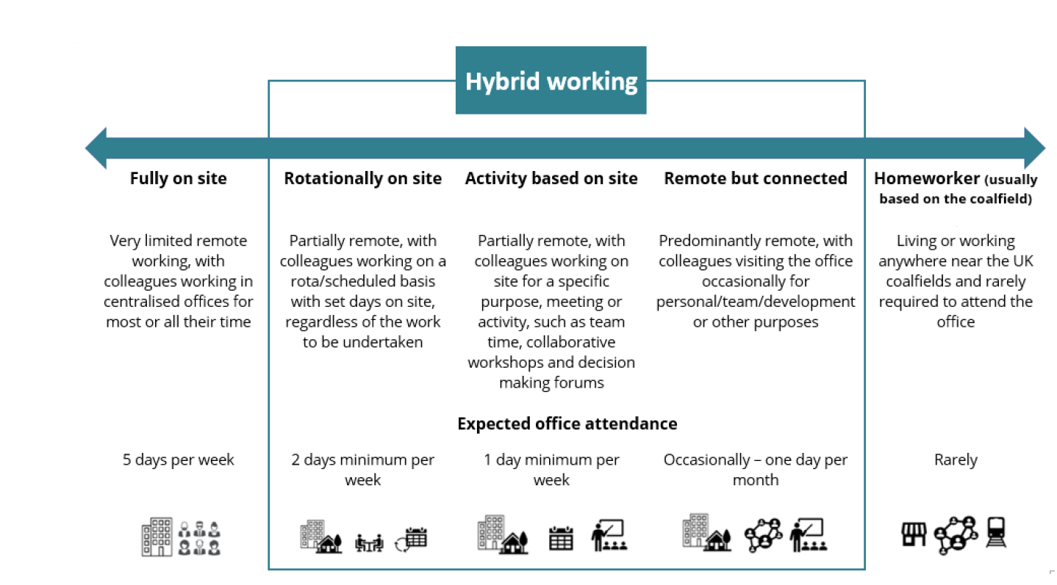

Person specification

Job Title: | Project Manager |  | Department: |  | Salinity
 | Essential |  | Desirable
Qualifications and Training | - No minimum qualification set if candidate can demonstrate relevant experience as required in the role  - Desire to continue to learn and develop professionally  - SMSTS or other Health and Safety Management qualification |  | - Degree or equivalent in relevant topic or Project Management qualification (e.g. APM, PRINCE2)  - Membership of a recognised professional body (APM, ICE or similar).
Experience and Knowledge | - Experience in the Project Management of the development and delivery of civil engineering projects  - Experience in developing clear scopes of work for project and programme activities  - Experience of managing conditions of contract  - Knowledge of HASAW Act 1974 and CDM Regulations 2015, and experience of managing safety on a construction site with confidence.  - Experience of dealing with contractors, technical experts, members of the public, MPs |  | - Experience of delivering significant civil engineering construction projects  - Experience of delivering water treatment or transfer schemes or linear pipeline infrastructure  - Experience of managing the NEC family of contracts
Skills and Abilities | - Project Management  - Collaboration and communication skills  - Presentation skills  - Report writing skills  - Negotiation skills  - Supervisory skills  - Financial monitoring and control  - Working to tight deadlines |  | - The ability to manage others and build relationships with external stakeholders.
Other | - Field Visits  - Occasional overnight stays  - Reasonable travel  - Use of PPE  - Full UK Driving License
 |  |  |  | 

