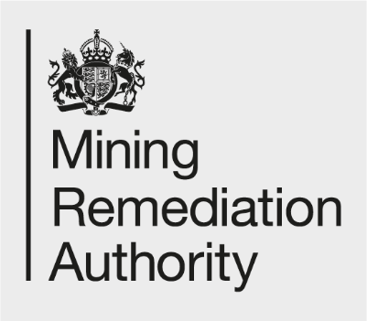

Job Title: Environmental Advisor – DESNZ Funded Activities
Department: Sustainability (Environmental Advisory Services Team)
Reports to: Environmental Advisory Services Team Lead
Direct Reports: None

Main purpose of the job

- Environmental Advisors provide specialist environmental assessment and management advice across the Mining Remediation Authority, supporting programme and project delivery, operations and property teams.
- They lead on the environmental assessment of individual projects and other work activities, ensuring appropriate ecological and environmental data is collected and used throughout the project lifecycle to minimise impacts (and identify benefits / positive opportunities where possible).
- They ensure that environmental regulations, policies and best practice are embedded into the design, delivery, operation and maintenance of mine water treatment and other mine legacy remediation schemes.
- They proactively identify and manage environmental risks and opportunities, promoting sustainable development principles across the full range of programmes and projects being delivered by the Mining Remediation Authority.
- Environmental Advisors also work collaboratively with internal teams, contractors and stakeholders, while acting as a key point of contact for environmental management / good practice matters and supporting site supervision, regulatory engagement, and quality assurance of all environmental aspects of the Mining Remediation Authority’s work.
- Specify and support third party site supervision, regulatory engagement and Environmental Clerk of Works activities. Technical audit and quality assurance of work delivered by consultants and contractors, working closely with specialists in other technical support teams.

Responsibilities

Specific:

- Working with Project Managers and wider project teams to provide advice and support relating to environmental (including but not limited to ecological, heritage and landscape) risks, constraints and opportunities during all stages of a project, including the development (scoping, feasibility, design, consenting, planning), construction and operational stages.
- Advising and inputting into the development and design of solutions, in order to reduce environmental impacts and increase the sustainability of projects and schemes, including consideration of multiple outcomes (optioneering) and increasing the benefits delivered.
- Provide colleagues with technical advice on environmental compliance and improvements on operational sites and other land occupied or owned by the Mining Remediation Authority (including mining spoil tips).
- Supporting and advising Programme Managers to ensure programmes, strategies and plans reflect relevant current environmental legislation and policy objectives and drivers.
- Scoping and supporting third party environmental studies and surveys needed to inform project works or operational activities. Interpretation of results and data arising, feeding into mitigation design and project development and design of maintenance and refurbishment activities on operational sites.
- Reviewing and assessing the adequacy and appropriateness of environmental information, reports and recommendations provided by Assistant level / less experienced colleagues, third party consultants and organisations, including regulatory bodies.
- Conducting site visits to complete ecological and environmental inspections to check on installation, maintenance and performance, on operational schemes and during construction activities. Supervising and supporting similar visits conducted by Assistant level / less experienced colleagues and non-technical Project Managers from across the organisation.
- Attending design, pre-start and other liaison meetings (virtual and on-site), to discuss ecological and other environmental protection and management issues, with other specialists, project management personnel, regulators and other stakeholders.
- Co-ordinating and managing the production of environmental consents and permits including relevant environmental screening, scoping and assessments required to inform applications.
- Liaising with internal and external stakeholders including governmental and regulatory bodies and partner organisations to ensure the timely and effective delivery of operational project, policy or strategy obligations.
- Co-ordinating and producing environmental risk management documentation (including RAMS) for projects and liaising with consultants and contractors to ensure implementation.
- Acting as a first point of contact and promoter on matters relating to ecological and other environmental management, protection and improvement. This includes working closely with our in-house teams to ensure compliance with Mining Remediation Authority environmental management requirements and objectives, including review and improvement of written procedures.
- To develop and maintain an expert technical knowledge of ecological and other environmental management design, policies and procedures, to assist in keeping individual projects and programmes up to date in terms of best practice. Production and maintenance of bespoke guidance and best practice methodologies for typical project activities in the context of Mining Remediation Authority work programmes.

General

- Represent the Mining Remediation Authority through the promotion of its vision, values and sustainability aims and aspirations to external bodies including through meetings, articles, presentations and conferences, sharing ideas to optimise outcomes and identify opportunities.

- Comply with Mining Remediation Authority policies and procedures as well as internal systems, particularly quality, safety and environmental policies and procedures, challenge and provide ideas for improvement if issues are identified.

- To act in accordance with the behaviours and values of the organisation (Trusted, Inclusive, Progressive).

- To manage your own performance to be accountable for meeting individual, team and corporate objectives.

- To act in accordance with the Scheme of Delegation and ensure propriety and regularity in the handling of public funds.

- To actively demonstrate the Mining Remediation Authority’s customer service standards expected of your role.

- To assist with the preparation and execution of the team’s objectives, budgets and financial records.

- To support research and development projects and maintain awareness of relevant external research and best practice.

- To support activities required to ensure that the Mining Remediation Authority’s statutory responsibilities are effectively discharged.

- To carry out any additional reasonable requests from your line manager.

Values in Action
We expect all our colleagues to embody our core values and behaviours in their daily work.
Trusted
- We act with integrity
- We’re open and transparent
- We deliver on our commitments
Inclusive
- We promote a culture of mutual respect
- We recognise that our differences make us stronger
- We work with others to achieve our vision
Progressive
- We’re open minded and innovative
- We recognise that the past can help us shape the future
- We listen and learn

Our Values in Action framework outlines important behavioural indicators which help us demonstrate our values through our work together.
Hybrid Working Model
This role sits within our Hybrid Working Model. The designated hybrid arrangement for this post is outlined under “Location” on page 1 of this Job Description and reflects the requirements of the role and the organisation. Hybrid working arrangements may be reviewed and adjusted if business needs change.
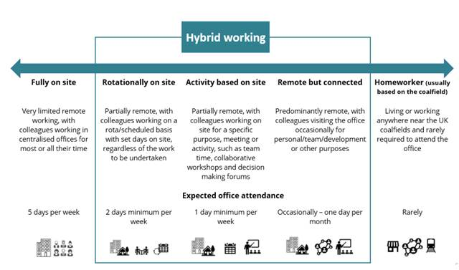

Person specification

Job Title: Environmental Advisor |  | Department: Sustainability
 | Essential | Desirable
Qualifications and Training | - Degree or equivalent qualification in relevant environmental discipline or demonstrable equivalent experience.  - Eligible for membership of a recognised professional body (CIEEM, IEMA or similar) with a route to chartered status. | - Master or postgraduate degree in relevant environmental discipline.  - Membership of a recognised professional body (CIEEM, IEMA or similar).  - Chartered Environmentalist status or other appropriate accreditation or actively working towards same.
Experience and Knowledge | - Working knowledge of environmental legislation in England, Scotland and Wales, relating to:  - Environmental Impact Assessment  - Habitats Regulations Assessment  - Working knowledge of policy drivers for environmental protection and improvement in England, Scotland and Wales.  - Experience of working on multidisciplinary projects, providing clear advice and recommendations to project teams relating to environmental planning and consenting requirements.  - Engaging with and managing multiple stakeholders including regulatory authorities and statutory stakeholders.  - Developing clear scopes of work for project and programme activities related to ecological and other environmental issues.  - Understanding of wider sustainability agendas in governmental and non-governmental organisations and related issues. | - Working knowledge and / or experience of  - Strategic Environmental Assessment  - Town and Country Planning legislation  - Specialism in a relevant technical environmental disciplines for example:  - Archaeology and Cultural Heritage  - Landscape  - Ecology  - Water quality and flood risk  - Previous experience working on pollution remediation infrastructure projects and / or water treatment schemes including wetlands / SuDS.  - Experience of undertaking Environmental Clerk of Works role during construction activities.  - Working in a programme and project management environment with Project Management experience.  - Experience / working knowledge of other sustainability considerations related to development projects including carbon management, Natural Capital, ecosystems services.  - Experience in contract management and / or managing external consultants and contractors.
Skills and Abilities | - Excellent research, planning and organisational skills.  - Strong attention to detail.  - Ability to work at pace.  - Strong interpersonal and communications skills.  - Positive team worker, but also able to work on own initiative.  - Able to manage multiple and often conflicting priorities to tight deadlines and a high standard.  - Full UK driving licence, willingness to travel to former mining areas across England, Scotland and Wales. | - The ability to manage others and build relationships with external stakeholders.  - Experienced GIS user.
