Job Title: | Senior Information Security Analyst
Department: | Digital
Reports to: | Information Security Manager and Assurance Lead
Direct Reports: | N/A
Location: | Activity Based On Site
Contract Type: | Permanent
Grade: | CA5

Main purpose of the job

- Support the organisation’s information security, cyber security and assurance activity by providing practical advice on threats, vulnerabilities, risks and controls across systems, services, projects and third parties.
- Lead and support security improvement activity in areas such as vulnerability management, incident response, risk treatment, control remediation and compliance with organisational policies, standards and good practice.
- Provide clear, proportionate and risk-based guidance to technical and non-technical stakeholders to support informed decision-making and the secure delivery of services.
- Contribute to a strong and auditable security posture through governance, reporting, assurance activity and continuous improvement.
- Work closely with colleagues across Digital and the wider organisation to help protect information, reduce risk and maintain trust in the organisation’s services and data.

Responsibilities

Specific
- Provide specialist advice and guidance on information security, cyber security and assurance matters affecting systems, services, projects, data and suppliers.
- Lead vulnerability management activity, including triage, prioritisation, remediation tracking and reporting, working with technical teams and suppliers to reduce risk.
- Manage security incidents through investigation, analysis, containment, escalation, lessons learned and follow-up actions.
- Manage the relationship with the third party Security Operations Centre provider.
- Undertake and support security risk assessments for new and existing systems, services, projects and exceptions, recommending appropriate and proportionate controls.
- Contribute to the development, review and maintenance of policies, standards, procedures and guidance to ensure they remain current, practical and aligned to organisational need.
- Support governance and assurance processes by preparing risk, compliance and control reporting for forums, audits, reviews and senior stakeholders.
- Maintain oversight of security actions and improvement plans, working with colleagues across Digital and the wider organisation to deliver measurable improvements.
- Monitor relevant threat information, alerts and good practice to identify emerging issues and support the organisation’s response.
- Provide security input into asset management, supplier assurance, change activity, exception handling and risk registers where required.
- Support colleagues by translating security requirements into practical guidance and by promoting awareness and good security practice.
- Act as a senior point of reference within the team, providing support, guidance and knowledge sharing to colleagues where appropriate.
- Manage the internal security toolsets applying continuous improvement to the quality of reporting. Regularly review the platforms for applicability and quality.
- Deputise for the Information Security Manager during holidays, sickness and as required.
- Stay up to date with departmental plans and strategies within Digital and other parts of the organisation to ensure information security can be maintained or enhanced.

General
- Act in line with the behaviours and values of the organisation.
- Manage your own performance to be accountable for meeting individual, team and corporate objectives.
- Act in accordance with the Scheme of Delegation and ensure propriety and regularity in the handling of public funds.
- Actively demonstrate the Mining Remediation Authority’s customer service standards expected of your role.
- Follow and contribute to the improvement of operational and team processes and procedures.
- Assist with the preparation and delivery of the team’s objectives, budgets and financial records.
- Identify opportunities and implement change leading to team development, system. improvement and ensuring good value for money.
- Maintain and develop positive stakeholder relationships in order to promote the Authority and assist it to meet its objectives.
- Support research and development projects.
- Ensure that the Authority’s statutory responsibilities are effectively discharged.
- Carry out any further reasonable requests from your line manager.

Values in Action
We expect all our colleagues to embody our core values and behaviours in their daily work.
Trusted
- We act with integrity
- We’re open and transparent
- We deliver on our commitments
Inclusive
- We promote a culture of mutual respect
- We recognise that our differences make us stronger
- We work with others to achieve our vision
Progressive
- We’re open minded and innovative
- We recognise that the past can help us shape the future
- We listen and learn
Our Values in Action framework outlines important behavioural indicators which help us demonstrate our values through our work together.
Hybrid Working Model
This role sits within our Hybrid Working Model. The designated hybrid arrangement for this post is outlined under “Location” on page 1 of this Job Description and reflects the requirements of the role and the organisation. Hybrid working arrangements may be reviewed and adjusted if business needs change.
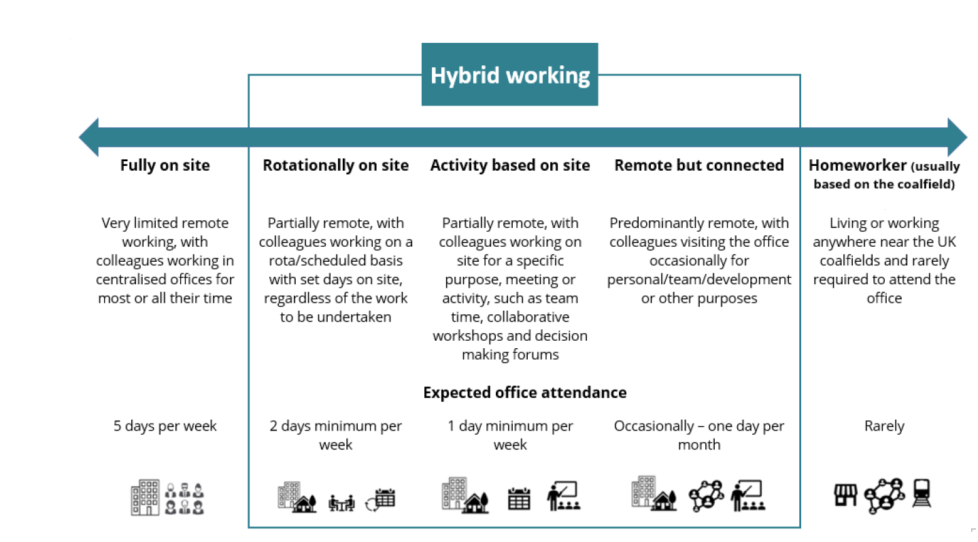

Person specification

Job Title: | Senior Information Security Analyst |  | Department: |  |  | Digital
 | Essential |  |  | Desirable
Qualifications and Training | - Degree-level qualification in cyber security, information security, computer science, digital or a related field, or equivalent practical experience.  - Relevant professional qualification, or willingness to work towards one, such as CISSP, SSCP, CISM, CRISC, Security+, ISO/IEC 27001 or equivalent. |  |  | - Membership of a relevant professional body.  - Training or accreditation in areas such as risk, audit, data protection, resilience or supplier assurance.
Experience and Knowledge | - Experience working in an information security, cyber security, assurance, governance, risk or compliance role.  - Good understanding of security risk management, control frameworks and the application of security policies and standards in practice.  - Experience of one or more of the following: vulnerability management, incident response, risk assessment, audit or assurance activity, supplier assurance, or security improvement planning.  - Ability to interpret security issues in a business context and provide pragmatic, risk-based advice.  - Experience of producing clear written outputs such as reports, risk assessments, briefing notes, policies or recommendations.  - Experience of managing a varied workload and delivering work to agreed deadlines. |  |  | - Knowledge of recognised frameworks or standards such as ISO/IEC 27001, NIST Cybersecurity Framework, the NCSC Cyber Assessment Framework or similar.  - Experience of working in a public sector, regulated or similarly complex environment.  - Knowledge of cloud services, identity and access management, data protection, resilience or secure change processes.
Skills and Abilities | - Strong communication and stakeholder management skills, with the ability to adapt style for technical and non-technical audiences.  - Good analytical and problem-solving skills, with the ability to assess evidence, identify options and recommend proportionate actions.  - Ability to influence and challenge constructively while maintaining effective working relationships.  - Strong organisation and planning skills, with the ability to manage multiple priorities and maintain attention to detail.  - Ability to work independently, use sound judgement and escalate matters appropriately where required. |  |  | - Experience of supporting or mentoring colleagues.  - Experience of presenting security, risk or assurance information to governance groups or senior stakeholders.
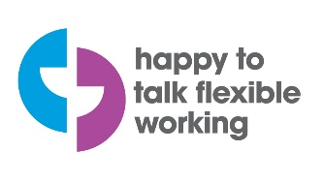 |  | 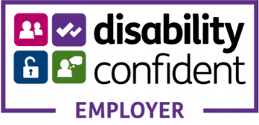 |  |  | 

