Job Title: | POD Adviser
Department: | People and Organisational Development (POD)
Reports to: | Principal POD Business Partner
Direct Reports: | None
Location: | Rotationally On Site
Contract Type: | Temporary
Grade: | CA4

Main purpose of the job

Provide professional people advice and practical support to managers and colleagues, helping ensure that people-related matters are managed fairly, consistently, legally and in line with organisational policies and values.

Responsibilities

Specific
- Advise managers and colleagues on all aspects of employee relations matters, including people policies and procedures, recruitment and selection, and conditions of employment.
- Support the management of employee relations cases, including undertaking investigations, preparing documentation, attending formal meetings and advising on a fair and consistent application of policies and legislation.
- Maintain oversight of the employee relations case management system, ensuring case records are kept up to date and supporting POD Business Partners in maintaining accurate and timely case management records.
- Advise managers in the application of attendance management procedures, including drafting correspondence, advising on process requirements and coordinating case documentation.
- Manage the flexible working request process, ensuring requests are handled fairly, consistently and in line with organisational policy and statutory requirements.
- Escalating high risk or complex employee relations matters to POD Business Partners as necessary.
- Assist the Business Partners with updating people policies and procedures in line with legislative changes.
- Ensure that POD Business Partners are keep updated on HR matters relating to the teams that they support, including workforce changes and any forecasting, in readiness for monthly People meetings.
- Undertake project work and research to support the POD team to continuously improve people processes and practices to support the People Plan.
- Promote the Mining Remediation Authority's values through all people-related activities, ensuring initiatives are implemented positively and in line with current ways of working.
- Acting as note-taker for formal meetings where needed, transcribing notes and sending to attendees for review.
- Conduct colleague engagement activities, including new starter check-ins, apprenticeship reviews and exit interviews, capturing feedback and identifying themes to support improvements to the colleague experience.
- Support colleagues to understand people initiatives and encourage engagement with change.

General
- Act in line with the behaviours and values of the organisation.
- Manage your own performance to be accountable for meeting individual, team and corporate objectives.
- Act in accordance with the Scheme of Delegation and ensure propriety and regularity in the handling of public funds.
- Actively demonstrate the Mining Remediation Authority’s customer service standards expected of your role.
- Follow and contribute to the improvement of operational and team processes and procedures.
- Assist with the preparation and delivery of the team’s objectives, budgets and financial records.
- Identify opportunities and implement change leading to team development, system. improvement and ensuring good value for money.
- Maintain and develop positive stakeholder relationships in order to promote the Authority and assist it to meet its objectives.
- Support research and development projects.
- Ensure that the Authority’s statutory responsibilities are effectively discharged.
- Carry out any further reasonable requests from your line manager.

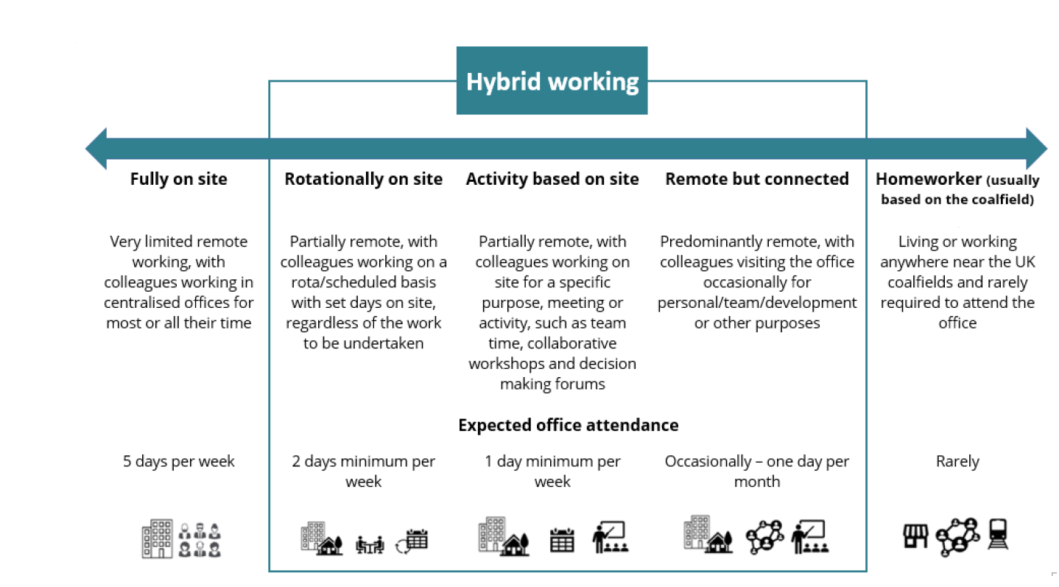
Values in Action
We expect all our colleagues to embody our core values and behaviours in their daily work.
Trusted
- We act with integrity
- We’re open and transparent
- We deliver on our commitments
Inclusive
- We promote a culture of mutual respect
- We recognise that our differences make us stronger
- We work with others to achieve our vision
Progressive
- We’re open minded and innovative
- We recognise that the past can help us shape the future
- We listen and learn
Our Values in Action framework outlines important behavioural indicators which help us demonstrate our values through our work together.
Hybrid Working Model
This role sits within our Hybrid Working Model. The designated hybrid arrangement for this post is outlined under “Location” on page 1 of this Job Description and reflects the requirements of the role and the organisation. Hybrid working arrangements may be reviewed and adjusted if business needs change.

Person specification

Job Title: | POD Adviser |  | Department: |  | POD
 | Essential |  | Desirable
Qualifications and Training | - CIPD qualification (or studying towards) Level 5 or demonstrable experience in HR practices
Experience and Knowledge | - Experience of managing or supporting a varied employee relations caseload, including disciplinary, grievance, sickness absence, capability and performance matters.  - Working knowledge of UK employment law, the Acas Code of Practice to ensure legally compliant employee relations processes.  - Experience of advising managers through employee relations procedures, including investigations, formal meetings, hearings, appeals and outcomes.  - Experience of interpreting and applying HR policies, procedures and terms and conditions of employment. |  | - Experience of using HR systems, including case management, recruitment or reporting systems  - Experience of supporting HR projects, process improvement or people plan activity.
Skills and Abilities | - Good communication, influencing and presentation skills  - Analytical and problem solving skills  - Ability to use Microsoft Office products  - Good organisational and administrative skills  - Ability to work under pressure and to deadlines  - Ability to build trusted relationships with stakeholders  - Strong organisation and prioritisation skills, with the ability to manage a busy caseload and meet deadlines
Other | - Observe strict confidentiality as required in the role  - Commitment to delivering excellent customer service  - Understanding and commitment to diversity within the workplace.
 |  |  |  | 

