Job Title: | Operations Manager – Metal Mines
Department: | Environment Operations
Reports to: | Senior Operations Manager
Direct Reports: | None
Location: | Remote but connected (home based)
Contract Type: | Permanent
Grade: | CA5

Main purpose of the job

- Have responsibility for the operation and maintenance of assets delivered through the Water and Abandoned Metal Mines (WAMM) Programme. This will be done via the Mining Remediation Authority (MRA) Operation and Maintenance Contract, which is an NEC4 Term Service Contract, or as otherwise directed.
- Ensure commitments to MRA clients, including the Environment Agency, Defra, Natural Resources Wales, and Welsh Government, are delivered diligently and in line with time, cost, quality, sustainability and MRA values.
- Escalate issues and risks that may affect health and safety, scheme performance, legal compliance, contract delivery, reputation, efficiency or WAMM programme objectives to the Senior Operations Manager.
- Manage internal and external relationships collaboratively and professionally.
- Support the Senior Operations Manager and wider WAMM programme team with the design and design review of new schemes, applying lessons learned from existing metal mine water treatment schemes and diffuse interventions.
- Work with the Senior Operations Manager to ensure schemes comply with current contracts and governance processes, engaging senior users or end users where required.

Responsibilities

Specific

- Act as NEC4 TSC Service Manager for allocated operational metal mine water treatment schemes and associated assets, ensuring the NEC4 Term Service O&M Contract scope is consistently delivered.
- Support the NEC4 TSC O&M Contract Performance Manager with contract negotiations and performance management issues.
- Assess monthly NEC contract payment applications, authorise invoices where appropriate and audit supporting evidence.
- Regularly audit works delivered under the NEC O&M Contract to provide assurance on compliance, quality and value.
- Manage other contracts or agreements relating to the operation and maintenance of metal mine operations team assets as required.
- Deliver selected projects with Senior Operations Manager oversight and support from the wider metal mines team.
- Maintain robust financial forecasting, planning, budget tracking, variance reporting and in-year budget delivery.
- Support the annual provisions exercise by providing Defra with accurate, evidenced operating and maintenance cost information for operational schemes.
- Develop and manage internal relationships with key stakeholders, including Technical Services, Property, SHW and Projects teams, to support scheme operation and project delivery.
- Support the Senior Operations Manager in managing relationships with key EA, Defra, NRW and Welsh Government stakeholders on scheme operation, maintenance and performance.
- Work with Technical Services and the Metal Mine R&D team to identify and deliver opportunities to optimise MWTS performance and apply learning across the MRA asset base where appropriate.
- Support ongoing work programmes with external collaboration partners, including Newcastle University and the National Trust.
- Drive continuous improvement, best value and accountability with our contractors.
- Prepare, procure and manage contracts as required, including ad hoc maintenance works, capital schemes and professional services, ensuring challenge, efficiency and value for money.
- Provide technical support for mine water treatment schemes, pumping operations, chemical and biological treatment, reed bed maintenance, and ochreous and organic waste management.
- Assist with the introduction of innovative technologies to improve operational efficiency and minimise waste disposal to landfill.
- Provide constructive challenge to contractors and consultants where necessary.
- Recognise business opportunities and promote the MRA brand.
- Maintain high standards of health, safety and wellbeing for yourself and site operations, undertaking regular site audits and ensuring appropriate follow-up actions are taken.

General
- Act in line with the behaviours and values of the organisation.
- Manage your own performance to be accountable for meeting individual, team and corporate objectives.
- Act in accordance with the Scheme of Delegation and ensure propriety and regularity in the handling of public funds.
- Actively demonstrate the Mining Remediation Authority’s customer service standards expected of your role.
- Follow and contribute to the improvement of operational and team processes and procedures.
- Assist with the preparation and delivery of the team’s objectives, budgets and financial records.
- Identify opportunities and implement change leading to team development, system. improvement and ensuring good value for money.
- Maintain and develop positive stakeholder relationships in order to promote the Authority and assist it to meet its objectives.
- Support research and development projects.
- Ensure that the Authority’s statutory responsibilities are effectively discharged.
- Carry out any further reasonable requests from your line manager.

Values in Action
We expect all our colleagues to embody our core values and behaviours in their daily work.
Trusted
- We act with integrity
- We’re open and transparent
- We deliver on our commitments
Inclusive
- We promote a culture of mutual respect
- We recognise that our differences make us stronger
- We work with others to achieve our vision
Progressive
- We’re open minded and innovative
- We recognise that the past can help us shape the future
- We listen and learn

Our Values in Action framework outlines important behavioural indicators which help us demonstrate our values through our work together.
Hybrid Working Model
This role sits within our Hybrid Working Model. The designated hybrid arrangement for this post is outlined under “Location” on page 1 of this Job Description and reflects the requirements of the role and the organisation. Hybrid working arrangements may be reviewed and adjusted if business needs change.
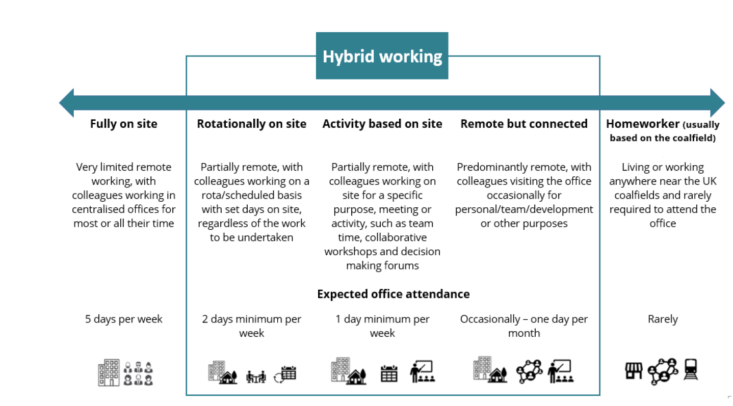

Person specification

Job Title: | Operations Manager – Metal Mines |  | Department: |  | Environment Operations
 | Essential |  | Desirable
Qualifications and Training | No minimum qualification set if candidate can demonstrate relevant experience as required in the role |  | - Accredited Service Manager (NEC3 or NEC4 Term Service Contract)  - Degree or equivalent in a relevant field, for example water and/or environmental management  - Membership of a relevant professional body, for example, CIWEM
Experience and Knowledge | - Experience managing operational assets, infrastructure, utilities, environmental sites or industrial facilities.  - Experience managing contractors, suppliers or service delivery partners.  - Experience monitoring budgets, financial forecasts and expenditure.  - Experience identifying, managing and escalating operational risks.  - Experience working with a range of stakeholders and building effective working relationships.  - Knowledge of health, safety and environmental management requirements in an operational setting.  - Experience delivering continuous improvement and performance optimisation initiatives.  - Knowledge of contract management principles. |  | - Experience working within the water, wastewater, environmental, mining, remediation or wider utilities sectors.  - Experience managing assets on behalf of a client organisation.  - Knowledge and application of NEC contracts, particularly NEC4 Term Service Contracts.  - Experience working within a regulated environment.  - Knowledge of passive, biological and/or chemical water treatment processes, pumping systems, or environmental infrastructure.  - Experience managing capital improvement or maintenance projects.  - Experience working with environmental regulators, government bodies or public sector organisations.  - Knowledge of environmental permitting and compliance requirements.  - Experience supporting research, innovation or operational trials.  - Experience auditing operational activities, contractor performance or asset management processes.  - Experience preparing business cases, specifications or procurement documentation.
Skills and Abilities | - Strong communication and stakeholder management skills.  - Ability to critically assess technical, operational and financial information to support decision-making.  - Ability to influence, engage and challenge constructively.  - Strong organisational skills with the ability to manage competing priorities.  - Ability to work independently whilst collaborating effectively with multidisciplinary teams.  - Strong problem-solving and decision-making skills.  - Commercial awareness and a focus on achieving value for money.  - Ability to prepare clear reports and present information effectively. |  | - Ability to communicate complex technical concepts to non-technical audiences.  - Ability to identify opportunities for innovation and continuous improvement.  - Skills in analysing operational data and identifying performance trends.  - Project management skills, including planning, delivery and risk management.  - Ability to build consensus and achieve positive outcomes where there is no direct authority.  - Ability to develop and maintain effective working relationships across organisational boundaries.
Other | - A strong interest in environmental improvement, sustainability and emerging treatment technologies.
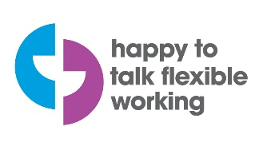 |  | 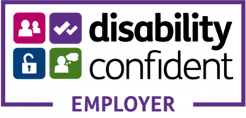 |  | 

