Job Title: | BSR PMO Analyst (Governance and Programme Controls)
Department: | Corporate Programme Office
Reports to: | BSR Programme Manager
Direct Reports: | None
Location: | Mansfield (Hybrid)
Contract Type: | Activity Based On Site
 | Fixed Term Contract to 31 March 2028
Grade: | CA4

Main purpose of the job

To support the Programme Manager in the delivery of the Business Systems Replacement (BSR) programme. To provide programme controls, governance assurance, analysis and performance reporting for the BSR. by maintaining effective programme controls, reporting, and governance processes. The role is responsible for analysing programme information, challenging assumptions, identifying emerging risks and issues, and providing insight to support effective decision-making by the Programme Manager, governance bodies and senior stakeholders. The postholder will work closely with workstream leads, SMEs, and suppliers to collate, maintain, and report programme information to support effective delivery and decision-making.

Responsibilities

Specific
- Programme Reporting: Produce and analyse programme performance information for the Programme Board, Design Authority and Assurance Boards. Challenge the quality and completeness of information provided by suppliers and workstream leads, identify emerging risks, trends and variances, and provide insight and recommendations to support programme decision making. Support alignment of supplier and internal reporting and planning outputs to ensure a consistent programme view.
- Planning and Tracking: Maintain and analyse the programme plan across multiple projects, workstreams and suppliers. Assess milestone achievement, critical path dependencies, resource impacts and schedule performance. Identify planning conflicts, delivery risks and resource constraints and escalate recommendations for action. Work with Project Managers, Suppliers, Workstream Leads, finance and the business planning team to ensure that robust programme and project plans are accurate and represent BSR plans during the MRA’s annual integrated planning process. Maintain the programme Plan on a Page (PoaP).
- Risk, Issue, Dependency (RAID): Maintain and assess programme risks, issues, assumptions and dependencies. Challenge the adequacy of mitigation plans, identify emerging themes and systemic risks, and provide analysis to support governance decisions and prioritisation activities.
- Governance Support: Plan, coordinate and prepare for governance forums, prepare packs and agendas, ensure actions, decisions and key outcomes are captured, tracked and followed through.
- Business Cases: Support and coordinate the development and/or revision of any Business Cases including the BSR Full Business Case and/or any related project business cases required.
- Change Control: Evaluate change requests and support assessment of impacts on cost, scope, schedule, risk, resources and expected benefits. Provide analysis to support recommendations to the Change Authority and Programme Board.
- Financial and Resource Tracking: Analyse programme expenditure, forecasts and resource demand against approved baselines. Investigate variances, identify areas of concern and provide analysis to support financial and delivery decision-making. Maintain resource plans and work with the Programme Team and suppliers in supporting the validation of resource assumptions and highlighting potential capacity risks or constraints. Work with the Programme Manager to support the annual cycle of integrated planning.
- Stakeholder Support: Work with the programme team, SMEs, suppliers and business departments to gather and validate programme information.
- Document Management: Maintain a well-structured programme document library with clear version control and naming conventions. Ensure all key programme artefacts are stored, accessible and up to date, including plans, reports, RAAID logs, decision logs and governance packs. Maintain the programme SharePoint site to ensure key programme information, documentation, and reporting are accessible, up to date, and structured to support internal stakeholders.
- Programme Communications: Manage the coordination and distribution of internal programme communications, ensuring relevant stakeholders are kept informed at the right time. Maintain a stakeholder and communications log and assist the Programme Manager in preparing key messages and updates.
- Benefits Tracking: Support the Business Lead and Programme Manager in maintaining the benefits register and tracking progress towards the realisation of benefits set out in the BSR Business Case. Ensure benefits are clearly linked to programme deliverables and that any changes to scope are assessed for their impact on expected benefits.

General
- Act in line with the behaviours and values of the organisation.
- Manage your own performance to be accountable for meeting individual, team and corporate objectives.
- Act in accordance with the Scheme of Delegation and ensure propriety and regularity in the handling of public funds.
- Actively demonstrate the Mining Remediation Authority’s customer service standards expected of your role.
- Follow and contribute to the improvement of operational and team processes and procedures.
- Assist with the preparation and delivery of the team’s objectives, budgets and financial records.
- Identify opportunities and implement change leading to team development, system. improvement and ensuring good value for money.
- Maintain and develop positive stakeholder relationships in order to promote the Authority and assist it to meet its objectives.
- Support research and development projects.
- Ensure that the Authority’s statutory responsibilities are effectively discharged.
- Carry out any further reasonable requests from your line manager.

Values in Action
We expect all our colleagues to embody our core values and behaviours in their daily work.
Trusted
- We act with integrity
- We’re open and transparent
- We deliver on our commitments
Inclusive
- We promote a culture of mutual respect
- We recognise that our differences make us stronger
- We work with others to achieve our vision
Progressive
- We’re open minded and innovative
- We recognise that the past can help us shape the future
- We listen and learn
Our Values in Action framework outlines important behavioural indicators which help us demonstrate our values through our work together.
Hybrid Working Model
This role sits within our Hybrid Working Model. The designated hybrid arrangement for this post is outlined under “Location” on page 1 of this Job Description and reflects the requirements of the role and the organisation. Hybrid working arrangements may be reviewed and adjusted if business needs change.
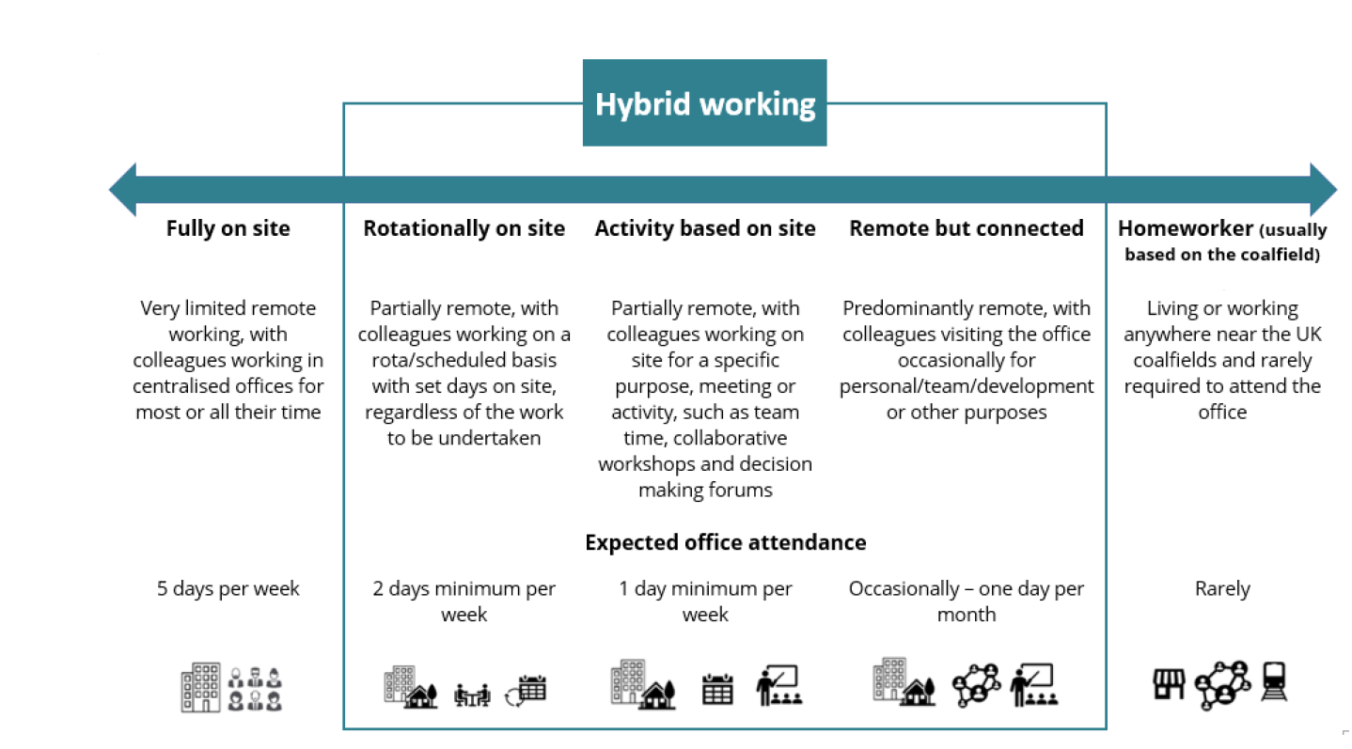

Person specification

Job Title: | BSR PMO Analyst |  | Department: |  | Corporate Programme Office
 | Essential |  | Desirable
Qualifications and Training | - 5 GCSEs or equivalent including Maths and English  - PRINCE2 / APM Foundation or Practitioner or equivalent project management qualification  - Evidence of continued professional development relevant to the role |  | - P3O Foundation or Practitioner
Experience and Knowledge | - Experience supporting Enterprise Resource Planning (ERP) implementations or major business transformation programmes  - Experience in a PMO role. Experience maintaining and analysing plans, reporting and governance artefacts  - Experience of working with or alongside external suppliers or implementation partners  - Strong knowledge of programme governance: RAID management, change control and milestone tracking |  | - Awareness of public sector governance, assurance and accountability frameworks  - Experience supporting business case development  - Project management experience
Skills and Abilities | - Demonstrable ability to analyse complex programme information, identify trends, challenge assumptions and provide recommendations to support decision making.  - Ability to adapt PMO tools and templates to the needs and maturity of the organisation  - Strong Microsoft Excel and PowerPoint skills  - Strong organisational skills with the ability to manage multiple priorities simultaneously  - Clear written and verbal communication skills; able to produce accurate reports and governance packs  - Ability to work independently and use initiative in a small programme team environment |  | - Influencing skills: able to encourage compliance with governance without formal authority  - Experience building programme documentation and ways of working from scratch
Other
 |  |  |  | 

