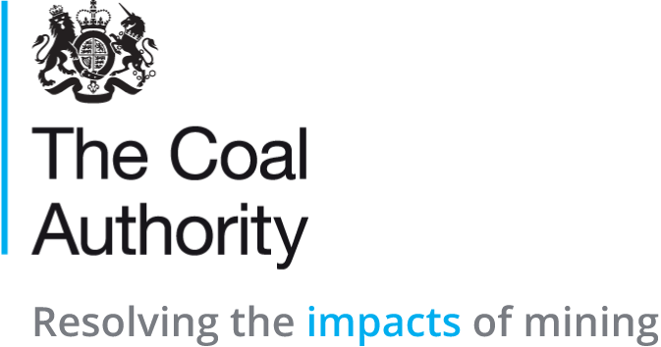

Job Title: Service Desk Analyst
Department: Digital
Reports to: Support Manager
Direct Reports: None

Main purpose of the job
To provide first-line support for Authority users and customers, giving advice and assistance with matters related to Digital services. Perform first-time fix on incidents where applicable and be the first point of contact for all matters related to tickets logged.
Support the Digital team, including Service Management with the progression of change activities and any other work to provide Digital services to the Authority.

Responsibilities
Specific
- Logging of all contact related to the provision of Digital services, for example incidents (faults), change requests and other ticket types using ITIL best practice.

- Be the first point of contact and the customer facing element of Digital and manage the tickets appropriately and depending on status - chasing resolver teams, routing calls intelligently and escalating where required. Give help / advice and follow-through on customer enquiries as appropriate, ensure that any issues and complaints are dealt with directly and politely.

- Responsibility for Authority issued iOS devices, including building, managing, supporting and ensuring compliance.

- Providing a Digital induction for new starters where they are issued with appropriate devices and shown how to navigate them and the Authorities Digital systems.

- Manage general communication and notification of any service outages with the customers, by liaising with suppliers and colleagues. Gather the latest information and then communicate this back via email, phone and in person. When talking to the customers, tailor your communications to ensure their understanding dependent on their knowledge of IT or the services in question.

- Provide technical support, assistance, advice and fixes to customers. Support includes, but not limited to, providing assistance with user passwords, releasing quarantined email, user mailbox assistance and troubleshooting by viewing the screen of the customer using the appropriate tools.

- Perform daily tasks, most of which are related to the monitoring of various systems and generally ensure that items are progressing through the workflow and then the subsequent logging of any of these exceptions as an Incident to be dealt with as per the normal procedures.

- Ensure that the Service Desk is staffed during the support hours by working flexibly with colleagues within the Support Team to maintain cover as required.

- Where appropriate escalate any issues / concerns with service or customer complaints to the Service Management team or line manager, to ensure the right level of awareness and that the issue can be managed appropriately for the Authority.

- Perform the role defined for the Service Desk in the management of any major outages (P1 / P2 incidents) as well as any business continuity duties in the event of a DR situation.

- Production of reports to demonstrate the standard of service delivery and measure performance against SLA’s (Service Level Agreement), OLA’s (Operational Level Agreement) and KPI’s (Key Performance Indicators.

- Maintain, create and review the support articles in the KMS (Knowledge Management System) within the Service Desk tool. Check and update the CMDB (Configuration Management Database) to ensure that asset / user information is always updated when dealing with customers, so hardware, software licenses and other information required for compliance are accurate.

- Maintain the Service Desk procedures, to ensure that support processes and incident handling guides etc. are recorded for easy reference and as an auditable record for procedures.

- Provide administrative support to the Support team for tasks including, answering phones and taking messages, Wisdom DRA work, collecting post and keeping storage areas tidy and secure.

- Any other reasonable activities as requested by your line manager.

Competencies Level
Seeing the bigger picture - has an in-depth understanding and knowledge of how the role fits with and supports The Coal Authority’s business priorities | 2
Changing and improving - responsive, innovative and seek out opportunities for continuous improvement | 2
Making effective decisions - objective; uses sound judgement, evidence and knowledge to provide accurate, expert and professional advice in a timely manner | 2
Leading and communicating - leads from the front and communicates with clarity, conviction and enthusiasm | 2
Collaborating and partnering - creates and maintains positive, professional and trusting working relationships with a wide range of people, within and outside The Coal Authority, to achieve results | 2
Building capability for all - has a strong focus on continuous learning for self, others and the organisation | 2
Achieving commercial outcomes - has a commercial, financial and sustainable mind-set to ensure all products and services deliver added value and stimulate growth | 2
Delivering good value for money - achieves a good mix of quality and effectiveness for minimal cost and to improve return on investment | 2
Managing a quality service - plans, organises and manages their time and activities to deliver a high-quality customer experience | 2
Delivering at pace - delivers timely performance, with energy, and taking responsibility and accountability for high-quality outcomes | 2

Person specification

Job Title: Service Desk Analyst

Section/Department: ICT

 | Essential | Desirable
Qualifications and Training | NVQ / HND in administration / Information Technology or similar | ITIL foundation
Experience and Knowledge | Experience in administrative role, or managing requests / faults through to resolution  Experience in dealing with customers / third-parties to deliver services / products | Experience working within an IT / customer contact centre
Skills and Abilities | Ability to manage and coordinate requests for Change and Incidents through the use of IT systems  Good communication skills, confident speaking at all levels  Planning / Facilitation of meetings and workshops – chairing if / when appropriate | Report writing skills, for production of plans, progress reports, diagrams etc  Good IT skills
 | Ability to deal with and coordinate contractors and third-party suppliers

