Job Title: | Property & Estates Surveyor
Department: | Development and Planning
Reports to: | Principal Property Manager
Direct Reports: | N/A
Location: | Activity Based On Site
Contract Type: | Permanent
Grade: | CA5

Main purpose of the job

- Lead the acquisition, management and disposal of land and property interests that support the Mining Remediation Authority’s operational and strategic needs, including the forward programme of mine water schemes.
- Provide expert property advice, manage property-related risks and help shape a sustainable, effective land portfolio.
- Maintain a land base appropriate to enable the forward programme of minewater schemes to be built and operated and deliver existing operational requirements.
- Provide property and land advice across the Authority, manage risks and help maintain the operational land portfolio.

Responsibilities

Specific
- To acquire land and property interests to support operational programmes;
- To ensure the Authority’s statutory responsibilities relating to the Authority’s surface property, excluding shafts and tips, are properly managed, and when in line with the strategy, to dispose of non-operational land securing best terms reasonably available;
- To lead the effective management of property contracts and historic liabilities, including lease renewals, valuations, covenants, clawbacks, external consultants and litigation, ensuring appropriate advice, governance and value for money.
- To contribute to the delivery of the teams objectives through reviewing sites and providing timely advice to the Principal/Team Leader;
- To lead the day-to-day management of the operational land and property portfolio, ensuring that property records, contractual obligations, compliance requirements and associated risks are managed accurately and proactively.

General
- Act in line with the behaviours and values of the organisation.
- Manage your own performance to be accountable for meeting individual, team and corporate objectives.
- Act in accordance with the Scheme of Delegation and ensure propriety and regularity in the handling of public funds.
- Actively demonstrate the Mining Remediation Authority’s customer service standards expected of your role.
- Follow and contribute to the improvement of operational and team processes and procedures.
- Assist with the preparation and delivery of the team’s objectives, budgets and financial records.
- Identify opportunities and implement change leading to team development, system. improvement and ensuring good value for money.
- Maintain and develop positive stakeholder relationships in order to promote the Authority and assist it to meet its objectives.
- Support research and development projects.
- Ensure that the Authority’s statutory responsibilities are effectively discharged.
- Carry out any further reasonable requests from your line manager.

Values in Action
We expect all our colleagues to embody our core values and behaviours in their daily work.
Trusted
- We act with integrity
- We’re open and transparent
- We deliver on our commitments
Inclusive
- We promote a culture of mutual respect
- We recognise that our differences make us stronger
- We work with others to achieve our vision

Progressive
- We’re open minded and innovative
- We recognise that the past can help us shape the future
- We listen and learn
Our Values in Action framework outlines important behavioural indicators which help us demonstrate our values through our work together.

Hybrid Working Model
This role sits within our Hybrid Working Model. The designated hybrid arrangement for this post is outlined under “Location” on page 1 of this Job Description and reflects the requirements of the role and the organisation. Hybrid working arrangements may be reviewed and adjusted if business needs change.
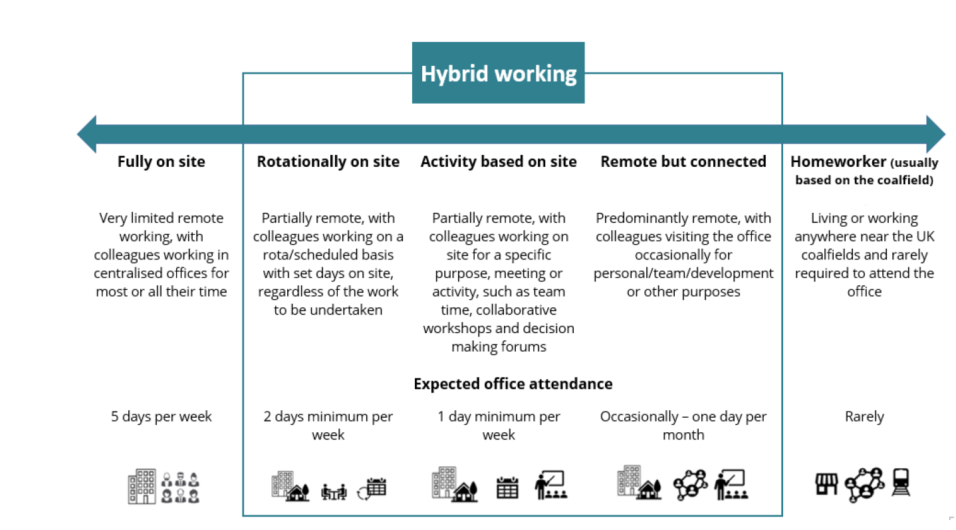

Person specification

Job Title: | Property & Estates Surveyor |  | Department: |  | Development and Planning
 | Essential |  | Desirable
Qualifications and Training | - Degree or equivalent professional qualification in a property-related discipline together with membership of, or active progression towards, the Royal Institution of Chartered Surveyors (MRICS).
Experience and Knowledge | - Experience of acquiring, managing and disposing of land and property interests.  - Experience of negotiating complex property transactions and securing best-value outcomes.  - Knowledge and practical application of leases, valuations, covenants, clawbacks and other property-related legal and contractual matters.  - Experience of managing property-related risks, compliance requirements and statutory responsibilities.  - Experience of building and maintaining effective relationships with landowners, local authorities, consultants and other stakeholders. |  | - Experience of using GIS / mapping programmes  - Experience in contract management  - Experience in property development/ land management
Skills and Abilities | - Ability to analyse complex property issues and develop practical, proportionate solutions.  - Ability to provide clear, evidence-based property advice to support operational and strategic decision-making.  - Strong stakeholder management and influencing skills.  - High levels of accuracy and attention to detail when managing contracts, records and compliance requirements.  - Ability to work independently, manage competing priorities and exercise professional judgement.  - Excellent negotiation skills  - Excellent report writing skills – able to produce clear, concise and evidence-based reports and professional advice.  - Ability to communicate complex property issues clearly to technical and non-technical audiences.  - Ability to prioritise a high volume, detailed workload  - Ability to build and maintain productive relationships with a wide range of stakeholders.  - Ability to work independently, exercise professional judgement and contribute effectively as part of multidisciplinary teams. |  | - Ability to work effectively in cross-functional multi-disciplinary teams
 |  |  |  | 

