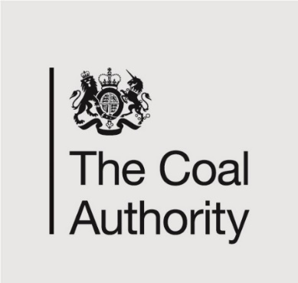

Job Title: SECRETARIAT GOVERNANCE OFFICER
Department: SECRETARIAT
Reports to: Secretariat Manager
Direct Reports: None

Main purpose of the job

The role will see you providing excellent governance support to the Executive Leadership Team, Board and its sub-committees, including support to organise, collate and issue all agendas and committee papers, take and distribute accurate minutes and update forward plans and action trackers as necessary to ensure service levels are adhered to at all times. You will also provide support to non-executive directors where required, and work alongside executive assistants to co-ordinate Executive Leadership Team members’ diaries and workflows.

You will

- Provide secretariat services to support the Board and its sub-committees, non-executive directors and the executive leadership team including managing diaries, organising meetings and appointments and being the first point of contact for pre-assigned groups as required.

- Collate and distribute papers, take and circulate minutes and be responsible for updating actions in the correct documents arising from those meetings in a timely manner.

- Provide such other support to the Chair of the Board and other non-executive directors as is necessary to ensure they are able to carry out their duties effectively.

- Contribute towards departmental objectives and team plans so that the Authority operates effectively and meets its corporate and governance objectives.

Responsibilities

You will:

- Plan and co-ordinate meetings for your pre-assigned groups. , Meetings will be assigned from the following Secretarial responsibilities :
  - Board
  - Audit, Risk and Compliance (ARAC), Annual Report and Accounts (ARAA), Chairs & Non Executive Directors (NED) Support, Executive Leadership Team (ELT) Business and People, ELT Strategy

  - Committees: People and Remuneration (P&R), Environment and Sustainability (E&S), Health Safety and Wellbeing (HSW) & Salinity Mine Water Programme Assurance Committee (SMWPAC)Administrative support duties

- Prepare draft agendas for approval that include all items, topics and papers. On time, to the required standard and in the correct format.

- Organise the publishing of correct agendas, papers and minutes in a timely manner, in the correct format.

- Manage personal workload to ensure the delivery of work to agreed deadlines

- Work with directors, their executive assistants and stakeholders to maintain a centralised forward plan of items, linked to action trackers to ensure that relevant papers are produced on time, for distribution in high quality electronic meeting packs.

- Co-ordinate and complete administrative duties to support the Secretariat function correctly and on time
- Take and produce accurate minutes in the approved format and tone for a variety of meetings (including decision making committees) across the business. Ensuring all quality control processes are followed to progress from draft to fully approved versions. Support the Business Planning, Risk and Governance department and your wider team in the provision of a high quality secretariat service and governance arrangements across the organisation.

- Acknowledge and deal with correspondence, producing draft responses where possible, whilst ensuring confidentiality at all times.

- Co-ordinate the submission of timely reports as and when required.

- Use appropriate systems to support process, efficiency and standards; including the adoption of new technologies in line with company policy

- Where appropriate, raise requisitions, manage purchase orders and receipting using the appropriate systems to ensure timely payment of invoices and expenses as per governance requirements.

- Undertake any other duties as requested by the Head of Board and Secretariat Manager and Executive Leadership Team.

General

- To act in accordance with the values, standards and behaviours of the Authority.

- To act in accordance with the Authority’s scheme of delegation and ensure propriety and regularity in the handling of public funds.

- To actively demonstrate the Mining Remediation Authority’s customer service standards expected of your role.

- To identify opportunities and implement change leading to team development, system improvement and good value for money.

- To maintain and develop positive stakeholder relationships in order to promote the Authority and assist it to meet its objectives.

- To ensure that the Authority’s statutory responsibilities are effectively discharged.

Person specification
Job Title: Executive Assistant (Governance) Department: Business Planning, Risk and Governance

 | Essential | Desirable
Qualifications and Training | Business Administration Level 3 or Equivalent office administration experience.  5 GCSE’s A-C or equivalent
Experience and Knowledge | Experience of operating in a fast paced environment. | Experience of supporting at Executive and, or Director level.  Experience of working in a highly governed organisation.
Skills and Abilities | Able to engage and communicate effectively with excellent writing skills.  Analytical and report writing skills.  Methodical, organised and accurate.  Ability to work remotely.  Ability to undertake and produce minutes.  To be resourceful and task-focused and able to problem-solve.  Ability to undertake and produce high quality minutes. | Advanced keyboard skills
Other | Willingness to undertake occasional travel to other Mining Remediation Authority locations, Governmental organisations, stakeholder visits and networking events.
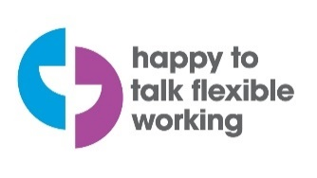

Competencies
As a partner organisation of the Department of Business, Energy and Industrial Strategy we use the Civil Service Competency Framework which describes the skills and behaviours expected of our staff and inform our staff development programme. If you would like to find out more of about these here is a link to the framework document. This document gives a description of what these competencies mean in practice and provides some examples of effective and ineffective behaviours at all levels. The levels run from 1 to 5 with level 1 describing the expectations and behaviours for staff in entry level roles, and level 5 those for the most senior roles. Level
Seeing the bigger picture - has an in-depth understanding and knowledge of how the role fits with and supports The Coal Authority’s business priorities | 2
Changing and improving - responsive, innovative and seek out opportunities for continuous improvement | 2
Making effective decisions - objective; uses sound judgement, evidence and knowledge to provide accurate, expert and professional advice in a timely manner | 2
Leading and communicating - leads from the front and communicates with clarity, conviction and enthusiasm | 2
Collaborating and partnering - creates and maintains positive, professional and trusting working relationships with a wide range of people, within and outside The Coal Authority, to achieve results | 2
Building capability for all - has a strong focus on continuous learning for self, others and the organisation | 2
Achieving commercial outcomes - has a commercial, financial and sustainable mind-set to ensure all products and services deliver added value and stimulate growth | 2
Delivering good value for money - achieves a good mix of quality and effectiveness for minimal cost and to improve return on investment | 2
Managing a quality service - plans, organises and manages their time and activities to deliver a high-quality customer experience | 2
Delivering at pace - delivers timely performance, with energy, and taking responsibility and accountability for high-quality outcomes | 2

