Job Title: | Programme Lead (Salinity)
Department: | Salinity
Reports to: | Principal Delivery Manager
Direct Reports: | Project Managers, Assistant Projects Managers
Location: | Activity Based On Site
Contract Type: | Temporary
Grade: | CA5+

Main purpose of the job

- To lead day-to-day delivery of projects within the Inland Saline Mine Water Programme, ensuring successful delivery of a portfolio of complex and interdependent projects that contribute to organisational objectives.
- Provide leadership and management to Project Managers and Assistant Project Managers, ensuring effective programme planning, governance, resource allocation, risk management and budget control.
- Provide support and assistance to the Principal Delivery Manager in shaping programme strategy, developing long term delivery plans and ensuring achievement of programme outcomes.
- Oversee workload planning, resource forecasting and prioritisation activities to ensure the efficient allocation of resources across the projects.
- Build and maintain effective relationships with internal and external stakeholders to support successful project outcomes and programme objectives.
- Mentor, develop and support Project Managers and Assistant Project Managers, promoting continuous professional development and capability growth within the team.

Responsibilities

Specific
- To lead and manage the delivery of the ISMWP projects, through programme, financial management, quality, reporting and risk management.
- Accountable for monitoring, forecasting and controlling programme expenditure, ensuring delivery within approved budgets and achievement of value for money
- Work with Principal Delivery Manager to manage internal relationships with key stakeholders such as the technical, property, commercial, stakeholder, HSW & operations teams with to resolve delivery challneges.
- Work with Principal Delivery Manager to manage relationships with key ISMWP stakeholders with regards to project delivery.
- Work collaboratively with the ISMWP Project Management Office and technical teams to ensure projects are compliant whilst ensuring governance, assurance and reporting arrangements are maintained across all projects.
- Identify and drive opportunities for continuous improvement, enhancing project delivery practices, efficiency and performance.
- Make recommendations regarding programme priorities, resource allocation and delivery sequencing.
- Identify additional skill requirements within the team required to successfully delivery of projects.
- The development, mentoring and coaching of the Project Manager and Assistant Project Managers.
- Undertake line management duties, performance reviews and set development plans.
- Setting individual objectives in line with departmental and corporate objectives.
- To deliver selected projects or work packages if required.
- Deputise for Principal Delivery Manager across programme governance, stakeholder engagement, resource planning and delivery performance management.
- Escalate strategic risks and issues while developing appropriate mitigation strategies.
- To carry out any further reasonable requests from your line manager.

General
- Act in line with the behaviours and values of the organisation.
- Manage your own performance to be accountable for meeting individual, team and corporate objectives.
- Act in accordance with the Scheme of Delegation and ensure propriety and regularity in the handling of public funds.
- Actively demonstrate the Mining Remediation Authority’s customer service standards expected of your role.
- Follow and contribute to the improvement of operational and team processes and procedures.
- Assist with the preparation and delivery of the team’s objectives, budgets and financial records.
- Identify opportunities and implement change leading to team development, system. improvement and ensuring good value for money.
- Maintain and develop positive stakeholder relationships in order to promote the Authority and assist it to meet its objectives.
- Support research and development projects.
- Ensure that the Authority’s statutory responsibilities are effectively discharged.
- Carry out any further reasonable requests from your line manager.

Values in Action
We expect all our colleagues to embody our core values and behaviours in their daily work.
Trusted
- We act with integrity
- We’re open and transparent
- We deliver on our commitments
Inclusive
- We promote a culture of mutual respect
- We recognise that our differences make us stronger
- We work with others to achieve our vision
Progressive
- We’re open minded and innovative
- We recognise that the past can help us shape the future
- We listen and learn
Our Values in Action framework outlines important behavioural indicators which help us demonstrate our values through our work together.
Hybrid Working Model
This role sits within our Hybrid Working Model. The designated hybrid arrangement for this post is outlined under “Location” on page 1 of this Job Description and reflects the requirements of the role and the organisation. Hybrid working arrangements may be reviewed and adjusted if business needs change.
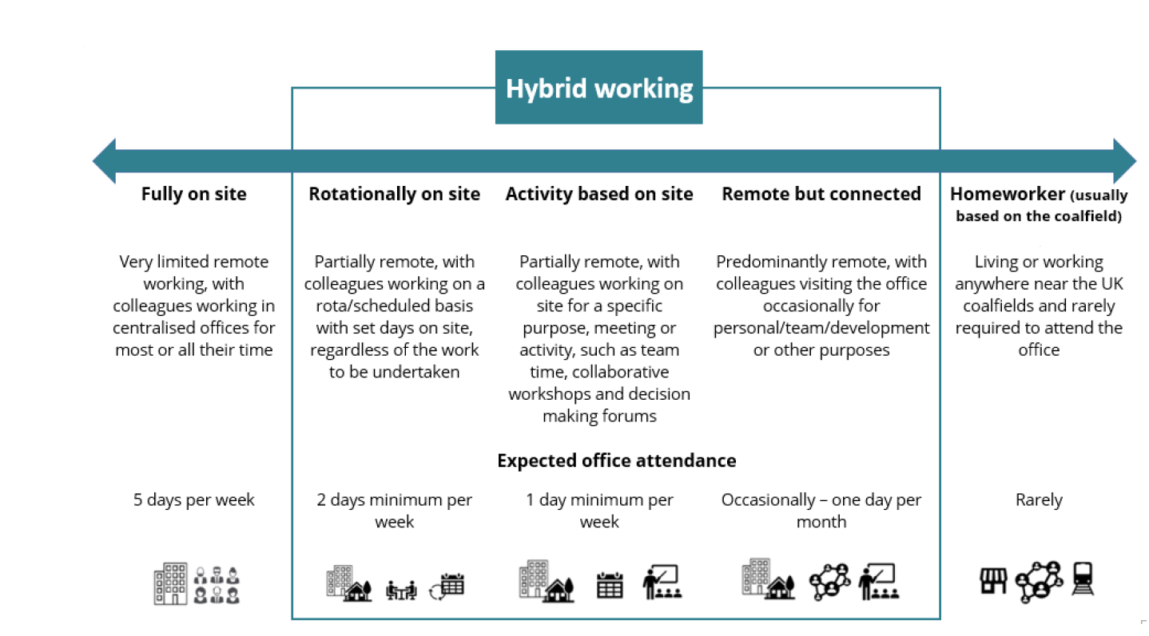

Person specification

Job Title: | Programme Lead (Salinity) |  | Department: |  | Salinity
 | Essential |  | Desirable
Qualifications and Training | - No minimum qualification set if candidate can demonstrate relevant experience as required in the role  - Desire to continue to learn and develop professionally |  | - Degree or equivalent in relevant topic or Project Management qualification (e.g. APM, PRINCE2)  - Membership of a recognised professional body (APM, ICE or similar).  - SMSTS or other Health and Safety Management qualification
Experience and Knowledge | - Experience in effective line management  - Experience managing complex portfolios of concurrent projects with competing priorities  - Experience leading multidisciplinary programmes and/or project delivery teams  - Experience of budget forecasting, financial monitoring and resource palnning  - An ability to manage and prioritise a high-volume workload & multiple projects  - Proven record of delivering projects from conception to build  - Experience of managing consultants and contractors through the NEC suite of contracts.  - Knowledge of HASAW Act 1974 and CDM Regulations 2015, and experience of promoting a positive safety culture. |  | - Experience of delivering environmental, civil engineering, infrastructure, utilities or large-scale remediation programmes  - Experience of working as a Client under CDM Regs  - Public sector experience  - Experience of reporting and presenting to Senior Leaders
Skills and Abilities | - Prioritisation and delegation  - Communication  - Excellent budget, programme & risk management skills  - Highly developed communication skills  - Interpersonal skills  - Self-motivation and excellent time management  - Team player, able to work with other teams to deliver the programme  - Liaison, negotiation and public presentation skills  - Report writing skills  - Resource and capacity management  - Influencing and negotiating across multidisciplinary teams  - Decisions making in complex and ambiguous environments  - Ability to balance operational delivery requirements with long term programme objectives |  | - Supporting the development of a programme of works
Other | - Field Visits  - Occasional overnight stays  - Reasonable travel  - Use of PPE  - Full UK Driving License
 |  |  |  | 

