Job Title: | Talent Acquisition Partner
Department: | People and Organisational Development (POD)
Reports to: | Principal POD Business Partner
Direct Reports: | None
Location: | Rotationally On Site
Contract Type: | Temporary – 12 months
Grade: | CA5

Main purpose of the job

As the Mining Remediation Authority continues to strengthen its approach to recruitment, talent attraction and workforce planning, this role will play a key part in ensuring we attract and secure the skills needed to deliver our strategic objectives. With a significant programme of recruitment activity planned over the coming months, the postholder will lead the delivery and continuous improvement of our recruitment service, whilst helping to build sustainable talent pipelines for the future. Working independently and as part of a supportive People and Organisational Development team, the role will partner closely with managers across the organisation to provide expert recruitment advice and practical support.

Responsibilities

Specific
- Deliver a consistent, compliant, high-quality and timely recruitment service across multiple live vacancies, balancing competing priorities and keeping hiring managers, candidates and POD colleagues informed throughout the process.
- Partner with hiring managers to plan, prioritise and deliver recruitment campaigns from vacancy approval through to offer, giving practical advice on attraction, selection, inclusive assessment and use of the Applicant Tracking System.
- Promote the Mining Remediation Authority in ways that reflect our values of trusted, inclusive and progressive, using inclusive recruitment methods, proactive attraction channels and targeted sourcing approaches to reach a broad and diverse candidate market.
- Coach and upskill managers as appropriate, ensuring they understand the attraction, recruitment and selection lifecycle and can use the Applicant Tracking System confidently and consistently.
- Proactively manage recruitment campaigns in line with our Recruitment Principles, keeping activity moving at pace, giving clear guidance on selection processes and ensuring good practice and legal compliance.
- Work with the POD Business Partners and managers to understand workforce planning requirements, future skills gaps and needs in order to forward plan any attraction campaigns and forecast headcount needs.
- Maintain the offer process, liaising with hiring manager to agree the offer and secure candidate acceptance
- Ensure that interview panel members have completed relevant interview training and that the panel make up is diverse, balanced and appropriate
- Build upon and drive appropriate inclusion strategies and initiatives, including but not limited to developing anonymous recruitment tasks/selection exercises to ensure unbiased selection
- Ensure that Job Descriptions are current and relevant before publishing
- Stay up to date with industry best practice by attending regular CPD events, ensuring our attraction and recruitment processes are innovative, in line with continuous improvement principles and meet our Everyday Inclusion plan aims
- Provide advice, guidance and hands-on delivery of attraction and sourcing campaigns, using appropriate advertising channels, LinkedIn Talent Solutions, professional networks and targeted search to improve reach, candidate quality and return on investment.
- Increase the proportion of quality direct hires year on year by using direct sourcing, candidate pipelining, LinkedIn Talent Solutions and effective campaign planning to reduce reliance on agencies where appropriate.
- Track, report and analyse recruitment activity, including vacancy volumes, time to hire, source of hire, candidate experience and campaign outcomes, using the insight to identify trends and improve the recruitment service.
- Maintain positive relationships with third party recruitment companies to ensure value for money and provision of high-quality candidates
- Attend recruitment networking events, careers events and professional forums to promote the Mining Remediation Authority’s employer brand and build talent pipelines for future vacancies.
- Lead the effective use and continuous improvement of the Applicant Tracking System, ensuring workflows support a positive candidate and hiring manager experience, reliable reporting and efficient recruitment administration.
- Work with the POD Support Officer to ensure that all offer letters, associated documentation and on-boarding processes are processed

General
- Act in line with the behaviours and values of the organisation.
- Manage your own performance to be accountable for meeting individual, team and corporate objectives.
- Act in accordance with the Scheme of Delegation and ensure propriety and regularity in the handling of public funds.
- Actively demonstrate the Mining Remediation Authority’s customer service standards expected of your role.
- Follow and contribute to the improvement of operational and team processes and procedures.
- Assist with the preparation and delivery of the team’s objectives, budgets and financial records.
- Identify opportunities and implement change leading to team development, system. improvement and ensuring good value for money.
- Maintain and develop positive stakeholder relationships in order to promote the Authority and assist it to meet its objectives.
- Support research and development projects.
- Ensure that the Authority’s statutory responsibilities are effectively discharged.
- Carry out any further reasonable requests from your line manager.

Values in Action
We expect all our colleagues to embody our core values and behaviours in their daily work.
Trusted
- We act with integrity
- We’re open and transparent
- We deliver on our commitments
Inclusive
- We promote a culture of mutual respect
- We recognise that our differences make us stronger
- We work with others to achieve our vision
Progressive
- We’re open minded and innovative
- We recognise that the past can help us shape the future
- We listen and learn
Our Values in Action framework outlines important behavioural indicators which help us demonstrate our values through our work together.
Hybrid Working Model
This role sits within our Hybrid Working Model. The designated hybrid arrangement for this post is outlined under “Location” on page 1 of this Job Description and reflects the requirements of the role and the organisation. Hybrid working arrangements may be reviewed and adjusted if business needs change.
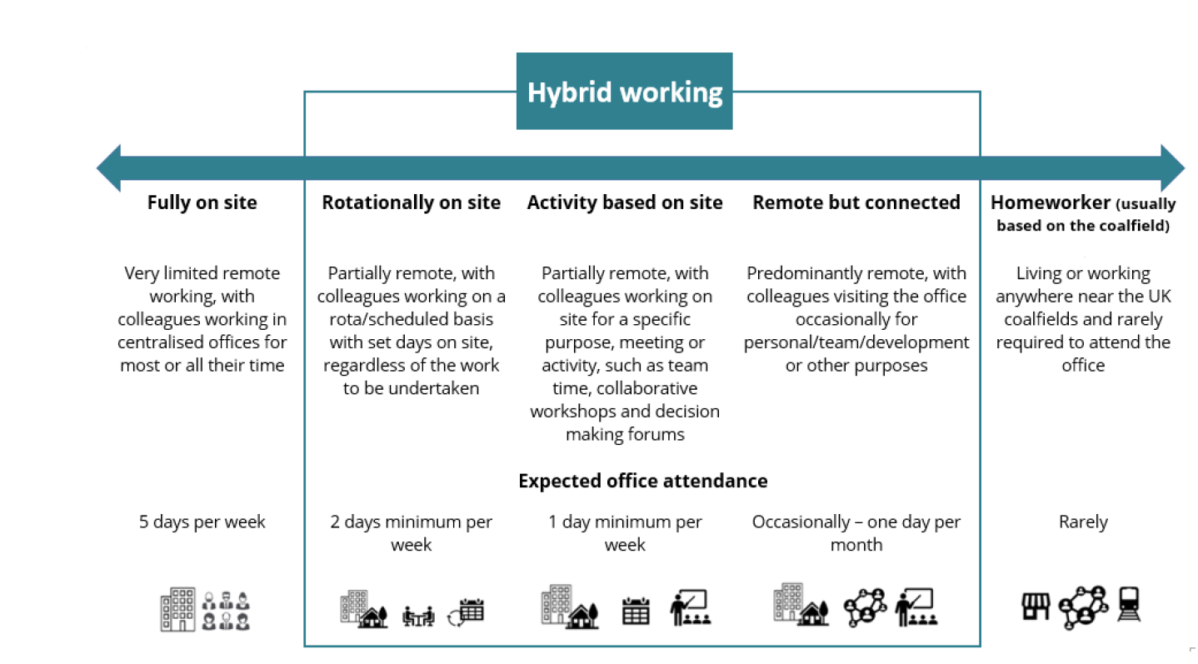

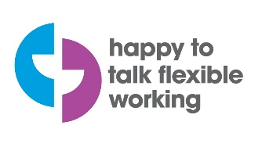 | 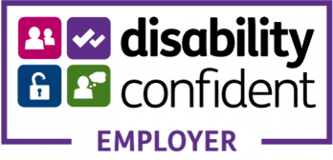 | 

Person specification

Job Title: | Talent Acquisition Partner | Department: | POD
Qualifications and Training | - Evidence of continuing professional development in recruitment, resourcing, talent acquisition, HR, workforce planning or a related field.
Experience and Knowledge | - Extensive recruitment experience, ideally within an in-house environment, with evidence of managing multiple vacancies and competing priorities at the same time.  - Proven experience of improving recruitment processes, candidate experience, hiring manager guidance or recruitment systems.  - Experience and knowledge of recruitment best practice, recruitment process, policy and relevant legislation, including GDPR, right to work and IR35.  - Experience of direct candidate attraction, proactive sourcing, candidate pipelining, LinkedIn Talent Solutions and networking approaches for hard-to-fill or specialist roles.
Skills and Abilities | - Confident user of Applicant Tracking Systems and digital recruitment tools, with the ability to maintain accurate records, run reports and identify opportunities to improve workflows.  - Proven ability to build and maintain positive relationships with people at all levels alongside effective communication skills – both written and verbal and able to deal  - Able to manage and prioritise a busy recruitment workload, balancing high vacancy volumes, urgent hiring needs and service quality.  - Have a flexible approach and ability to adapt to meet differing demands  - Able to work on own initiative and autonomously

