Job Title: | Finance Administrator
Department: | Finance
Reports to: | Principal Financial Accountant
Direct Reports: | N/A
Location: | Activity Based On-Site
Contract Type: | Permanent
Grade: | CA3

Main purpose of the job

Responsible for providing administrative and transactional support for the Finance team.

Responsibilities

Specific
Core areas of responsibility supporting the Financial Accounting team:

- To assist the Purchase Ledger Supervisor in the daily operation of the Accounts Payable:
  - Transaction processing – three-way match of invoices (to Purchase Order and receipt) and to ensure cheque requisitions are appropriately accounted for in a timely manner.
  - Supplier settlement – ensuring that payments are correctly processed through weekly BACS payment runs and processing of CHAPS/Faster Payment.

- To check and process Employee Expense claims in line with the Expenses Policy.

- To check and process Government Procurement Card (GPC) Expenses in line with the GPC Policy.

- To provide any ad-hoc administrative support within the Finance team.

- To provide cover during periods of absence/holidays with colleagues.

General
- Act in line with the behaviours and values of the organisation.
- Manage your own performance to be accountable for meeting individual, team and corporate objectives.
- Act in accordance with the Scheme of Delegation and ensure propriety and regularity in the handling of public funds.
- Actively demonstrate the Mining Remediation Authority’s customer service standards expected of your role.
- Follow and contribute to the improvement of operational and team processes and procedures.
- Assist with the preparation and delivery of the team’s objectives, budgets and financial records.
- Identify opportunities and implement change leading to team development, system. improvement and ensuring good value for money.
- Maintain and develop positive stakeholder relationships in order to promote the Authority and assist it to meet its objectives.
- Support research and development projects.
- Ensure that the Authority’s statutory responsibilities are effectively discharged.
- Carry out any further reasonable requests from your line manager.

Values in Action
We expect all our colleagues to embody our core values and behaviours in their daily work.
Trusted
- We act with integrity
- We’re open and transparent
- We deliver on our commitments
Inclusive
- We promote a culture of mutual respect
- We recognise that our differences make us stronger
- We work with others to achieve our vision
Progressive
- We’re open minded and innovative
- We recognise that the past can help us shape the future
- We listen and learn
Our Values in Action framework outlines important behavioural indicators which help us demonstrate our values through our work together.
Hybrid Working Model
This role sits within our Hybrid Working Model. The designated hybrid arrangement for this post is outlined under “Location” on page 1 of this Job Description and reflects the requirements of the role and the organisation. Hybrid working arrangements may be reviewed and adjusted if business needs change.
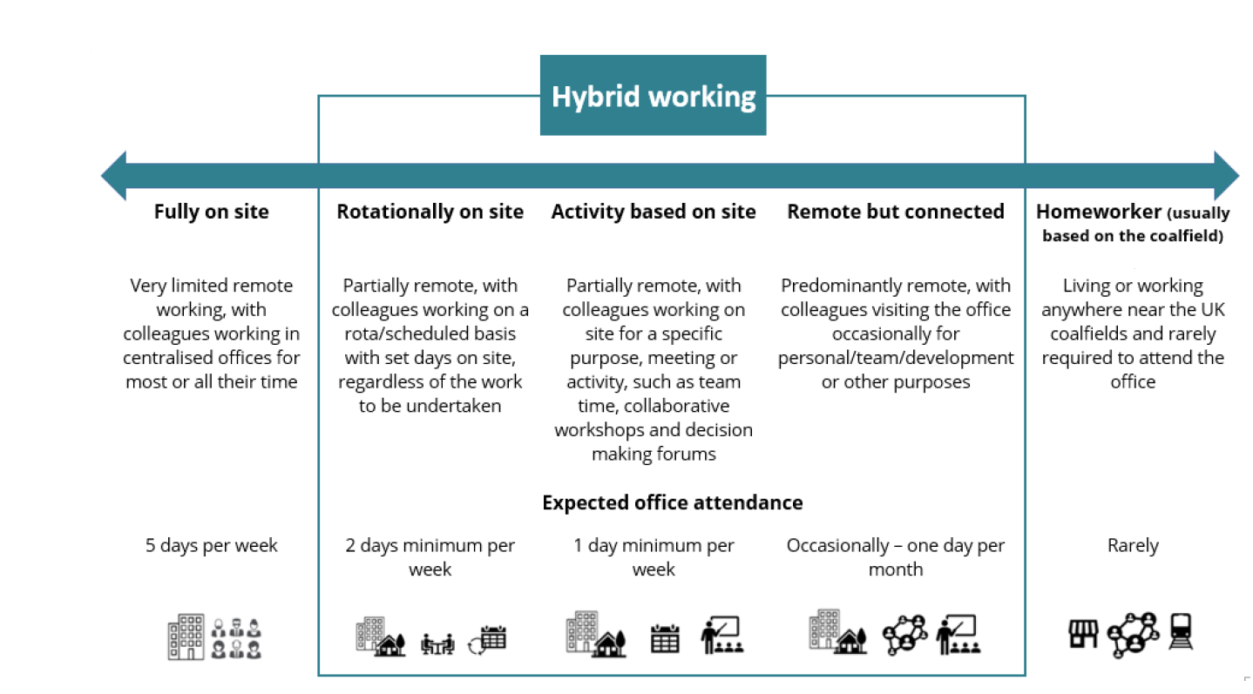

Person specification

Job Title: | Finance Administrator |  | Department: |  | Finance
 | Essential |  | Desirable
Qualifications and Training | - GCSEs (or equivalent) at Grade C or above in Maths & English. |  | - A Level (or equivalent) in relevant subjects.
Experience and Knowledge | - Previous experience of working in a finance team, covering similar tasks to the job description. |  | - Principles and concepts of Accountancy / Finance.
Skills and Abilities | - Excellent inter-personal / communication skills.  - Ability to work under pressure, prioritise workload and achieve deadlines.  - Attention to detail and good organisational / planning skills.  - Proficient in the use of IT and systems (including Microsoft Office applications). |  | - Builds and maintains relationships / networks and delivers a quality service.  - Flexible and adaptable to changing priorities and culture of improvement and change.
 |  |  |  | 

