Job Title: | Executive Assistant
Department: | Executive Leadership Team (ELT)
Reports to: | Relevant Director
Direct Reports: | None
Location: | Rotationally On Site
Contract Type: | Temporary
Grade: | CA4

Main purpose of the job

The role ensures the effective running and management of one of our executive offices and / or major programmes and provides cover to manage other executive offices.
It is responsible for providing a proactive, professional executive assistant support service to our chief executive, directors, major programmes or chair / non-executive board members.

Responsibilities

Specific
- Manage and run the office of one member of our executive leadership team (ELT) or support the offices of our chair / non-executive board member(s) or support a major programme in line with resources and requirements, providing professional executive support.
- Ensure strategic and operational meetings are effectively planned and managed, including collating agendas, distributing of papers, taking of accurate minutes, maintaining action trackers, ensuring any accessibility needs are supported and that technical solutions are provided where required.
- Effectively manage multiple inboxes and coordinate diaries to support organisational priorities; prioritising emails and responding when necessary.
- Make phone calls on behalf of ELT members (eg to MPs’ offices), and answer and respond to calls to the chief executive and directors.
- Work with internal and external contacts to arrange meetings, site visits and events for staff and strategic stakeholders – coordinating of all aspects of events and visits arrangements, including action plans, bookings and travel.
- Lead on coordinating specific projects on behalf of ELT / board, within the timescales set and to the standards required.
- As part of the executive assistants’ team, continuously develop the executive offices together to improve forward planning and create efficiencies.
- Work as one team, sharing skills and knowledge with others, to ensure resilience, appropriate cover and enable duties to be carried out effectively.
- Manage the processes for correspondence to the ELT / board (including high profile / key stakeholder correspondence) and ensure relevant actions are undertaken by colleagues across the organisation in line with our customer standards.
- Work with ELT and heads of departments to support their work with ministers, elected mayors, MPs, MSPs, MSs, chief executives and other strategic stakeholders. This includes: arranging meetings; speaking to stakeholders and their offices; and collating and issuing correspondence and updates on our work.
- Work with our wider Executive Support team to ensure effective strategic stakeholder engagement.
- Communicate effectively to a wide range of colleagues and stakeholders, maintaining a professional manner that reflects our values and behaviours.
- Ensure confidentiality, accurate record keeping and governance, in line with our policies and procedures.
- Undertake any other duties as requested.

General
- Act in line with the behaviours and values of the organisation.
- Manage your own performance to be accountable for meeting individual, team and corporate objectives.
- Act in accordance with the Scheme of Delegation and ensure propriety and regularity in the handling of public funds.
- Actively demonstrate the Mining Remediation Authority’s customer service standards expected of your role.
- Follow and contribute to the improvement of operational and team processes and procedures.
- Assist with the preparation and delivery of the team’s objectives, budgets and financial records.
- Identify opportunities and implement change leading to team development, system. improvement and ensuring good value for money.
- Maintain and develop positive stakeholder relationships in order to promote the Authority and assist it to meet its objectives.
- Support research and development projects.
- Ensure that the Authority’s statutory responsibilities are effectively discharged.
- Carry out any further reasonable requests from your line manager.
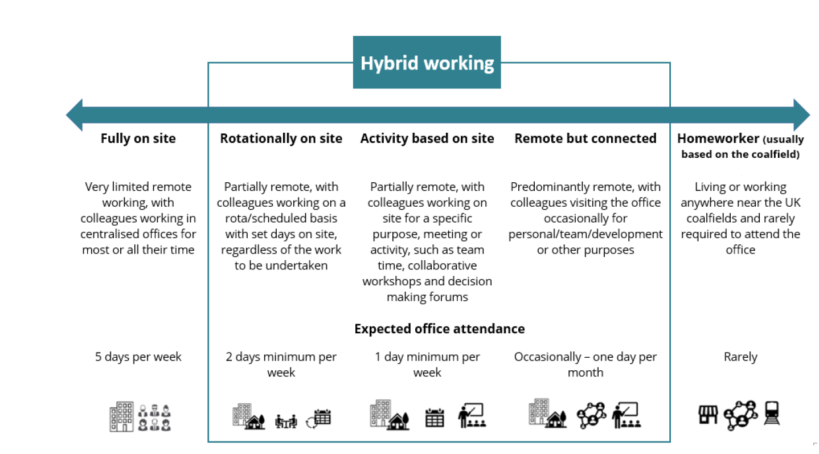
Values in Action
We expect all our colleagues to embody our core values and behaviours in their daily work.
Trusted
- We act with integrity
- We’re open and transparent
- We deliver on our commitments
Inclusive
- We promote a culture of mutual respect
- We recognise that our differences make us stronger
- We work with others to achieve our vision
Progressive
- We’re open minded and innovative
- We recognise that the past can help us shape the future
- We listen and learn
Our Values in Action framework outlines important behavioural indicators which help us demonstrate our values through our work together.

Hybrid Working Model
This role sits within our Hybrid Working Model. The designated hybrid arrangement for this post is outlined under “Location” on page 1 of this Job Description and reflects the requirements of the role and the organisation. Hybrid working arrangements may be reviewed and adjusted if business needs change.

Person specification

Job Title: | Executive Assistant |  | Department: |  | Executive Leadership Team
 | Essential |  | Desirable
Experience and Knowledge | - Experience of supporting directors, chief executives or senior leaders (eg MPs)  - Experience of developing positive relationships with internal and/or external customers and stakeholders |  | - Experience of planning and delivering on projects or implementing changes into an organisation
Skills and Abilities | - Excellent organisational skills, with the ability to work accurately to a high standard  - Resourceful, task focused, able to problem solve and prioritise to meet deadlines  - Confident communicator, able to work at all levels across the organisation  - Advanced skills in MS Office with ability to support report writing, and produce accurate minutes  - Positive team worker with the ability to work with others, across the organisation and externally, confidentially  - Good time management skills and the ability to work to deadlines  - Ability to work at pace and with flexibility |  | - Occasional travel to other locations, government organisations, stakeholder visits and networking events  - Proactive self-starter who takes the initiative to horizon scan, and identify opportunities to instigate change
Other
 |  |  |  | 

