Job Title: | Senior Customer Strategy and Support Manager
Department: | Customer Support and Services
Reports to: | Head of Customer Support and Services
Direct Reports: | Up to 4
Location: | Activity Based On Site
Contract Type: | Permanent
Grade: | CA5+

Main purpose of the job

As the Senior Customer Strategy and Support Manager you will be a strong people leader managing a team of customer service professionals dealing with a wide range of customer enquiries at first point of contact through various channels, providing a high level of customer service ensuring customer right first-time resolution.
You will be responsible for customer and official correspondence, complaint resolution, incident support and the development and implementation of strategy. You will also support the Head of Customer Support and Services in effective financial management, horizon scanning, and providing performance commentary for the department.
You will make sure that we maintain our high standards of service and hold strong relationships across the organisation to coordinate the production of information and delivery of our services to agreed standards and you will lead a team in the successful delivery of departmental and corporate strategies and objectives
Responsibilities

Specific
- You will set the team direction and undertake all line management activities, providing leadership to the strategy and support team in delivering and promoting a strong values and customer focused team culture including developing and upskilling the team.
- Accountable for the setting and achievement of the team assigned targets, service performance and achievement of the teams overall objectives.
- Proactively establish cross working relationships with departments throughout the Mining Remediation Authority, to align goals and approaches that facilitate a smooth achievement of key objectives.
- Proactively manage the team in triaging and prioritising workload to ensure the efficient and effective delivery of activity in line with agreed service levels. Ensuring the smooth running of the teams day-to-day functions, its people and processes.
- You will produce correspondence on behalf of the Executive Leadership Team and CEO.
- You will support with proactive MP, MSP, MS and elected representative correspondence to maintain strong relationships. You will be comfortable with National and Local Government operations and expected to identify opportunities to build and enhance the reputation of Mining Remediation Authority within this area.
- You will ensure the Community website pages are up to date and keep communities impacted by mining related incident kept up to date at all times.
- Support the organisation to be able to react and respond to major incidents and hazard situations, supporting the needs of residents and other departments across the organisation.
- You will provide delegated support to the Head of Customer Support and Services in leading the department as required e.g. during absence cover or representation at external events or stakeholder meetings.
- Assist in the delivery of the customer plan with the Head of Customer Support and Services.
- You will be the main point of contact across key functions to ensure a high level of customer service, championing a customer focused culture.
- You will work with the Customer Strategy Coordinator in identifying improvement plans across departments to make sure our services are accessible for all.
- You will manage complaint responses and ensure a fair outcome has been achieved while providing an exceptional level of customer service in accordance with our customer standards and tone. At times, you will also be required to communicate with customers directly in a professional and empathetic manner; either by phone or face to face.
- Actively support with the delivery of the Customer Delivery Groups objectives across the whole organisation at a strategic and operational level.
- Serve as a role model by displaying good judgment, positive work ethic, strong interpersonal skills, adherence to policies and demonstrates a commitment to excellent customer service.
- Produce and analyse monthly statistics or other data to determine the level of customer service the team is providing.
- You will act with discretion and maintain confidentiality of correspondence.
- You will help define and integrate clear structures, systems required to meet customer needs and wants, creating a positive customer experience and removing obstacles where necessary.
- You will produce documents to a high standard using the appropriate software, including the following but not limited to; MS Office, PowerPoint, Excel.

General
- Act in line with the behaviours and values of the organisation.
- Manage your own performance to be accountable for meeting individual, team and corporate objectives.
- Act in accordance with the Scheme of Delegation and ensure propriety and regularity in the handling of public funds.
- Actively demonstrate the Mining Remediation Authority’s customer service standards expected of your role.
- Follow and contribute to the improvement of operational and team processes and procedures.
- Assist with the preparation and delivery of the team’s objectives, budgets and financial records.
- Identify opportunities and implement change leading to team development, system. improvement and ensuring good value for money.
- Maintain and develop positive stakeholder relationships in order to promote the Authority and assist it to meet its objectives.
- Support research and development projects.
- Ensure that the Authority’s statutory responsibilities are effectively discharged.
- Carry out any further reasonable requests from your line manager.

Values in Action
We expect all our colleagues to embody our core values and behaviours in their daily work.
Trusted
- We act with integrity
- We’re open and transparent
- We deliver on our commitments
Inclusive
- We promote a culture of mutual respect
- We recognise that our differences make us stronger
- We work with others to achieve our vision
Progressive
- We’re open minded and innovative
- We recognise that the past can help us shape the future
- We listen and learn
Our Values in Action framework outlines important behavioural indicators which help us demonstrate our values through our work together.
Hybrid Working Model
This role sits within our Hybrid Working Model. The designated hybrid arrangement for this post is outlined under “Location” on page 1 of this Job Description and reflects the requirements of the role and the organisation. Hybrid working arrangements may be reviewed and adjusted if business needs change.
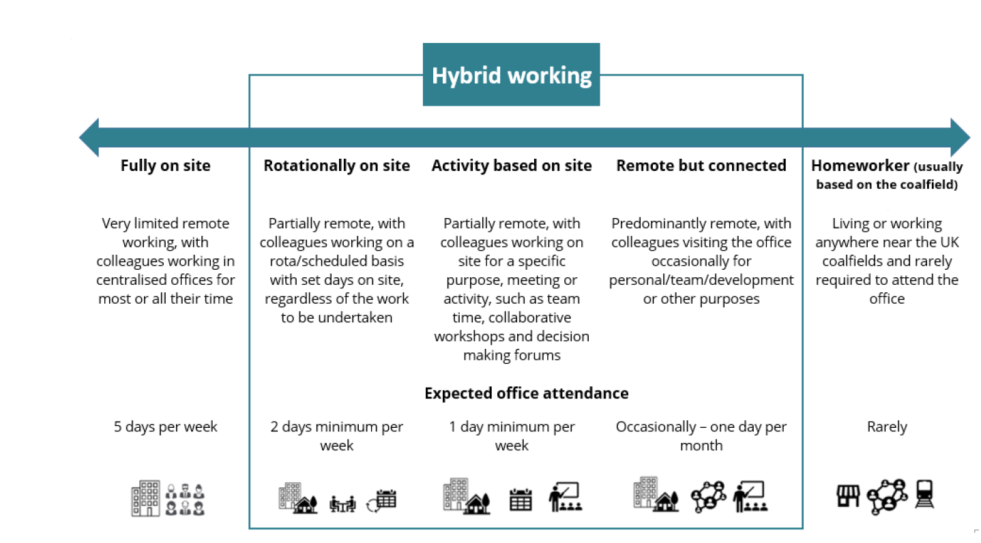

Person specification
Job Title: | Senior Customer Strategy & Support Manager |  | Department: |  | Customer Support and Services
 | Essential |  | Desirable
Qualifications and Training | - GCSEs grades A – C (to include English & Maths).  - Proficiency in MS Office (Intermediate Level).  - Excel proficient  - NVQ/ Diploma customer service or significant experience in a relevant industry or field |  | - Knowledge of accessibility regulations WCAG2.1
Experience and Knowledge | - Experience of working with key stakeholders across a wide range of organisations  - Experience of managing a structured complaints handling process  - Workload triaging and prioritisation  - Managing robust records  - Substantial experience of managing performance against budgets/targets  - Experience of delivering against service level agreements  - Experience and knowledge of communicating with National and Local Government  - 3-5 years in a customer service environment  - Champion opportunities to consistently improve customer experience  - Experience of driving continuous improvement within customer services |  | - Knowledge of GDPR, Data protection  - Knowledge of accessibility regulations WCAG2.1  - Knowledge of mining products  - Operational background /understanding of operational organisations  - Customer Survey analysis  - Knowledge or awareness of the Public Sector
Skills and Abilities | - Strong leadership skills  - Values based leadership approach  - Excellent written and verbal communication skills  - Strong organisational and planning skills.  - Ability to use positive language  - Ability to demonstrate patience  - Ability to analyse data from a variety of sources and complex scenarios  - Excellent stakeholder management experience, working at all levels - both internally and externally  - Emotionally intelligent, with an understanding and concern for others, with the ability to sometimes take a neutral view of emotive and distressing issues  - Ability to work under pressure  - Flexibility to adapt quickly in response to change |  | - Multi agency emergency response experience
Other | - Flexibility to meet the requirements of the job.
 |  | 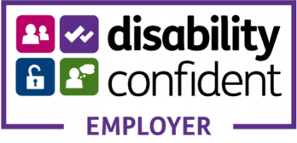 |  | 

