Job Title: | Finance Assistant
Department: | Finance
Reports to: | Principal Financial Accountant
Direct Reports: | N/A
Location: | Activity Based On-Site
Contract Type: | Permanent
Grade: | CA3

Main purpose of the job

Responsible for providing administrative and transactional support for the Finance team.

Responsibilities

Specific
Core areas of responsibility supporting the Financial Accounting and Payroll team:

- Accounts Receivable:
  - Accounts Receivable ledger and associated transaction processing – timely production of invoices and credit notes and undertaking key customer monitoring to manage exposure to credit risk.

- Bank Postings:
  - Ensuring that payments and receipts are correctly recorded and processed in the ledgers.
  - Notifying the wider business of payments being received.

- Government Procurement Cards (GPC):
  - GPC admin – Opening/closing card accounts and managing GPC limits.
  - Loading GPC statement into the Time@Work system.
  - Processing GPC claims in line with the approved policy and posting to the general ledger.
  - Chasing employees for missing forms and resolving queries in a timely manner.

- Payroll Support:
  - Payroll processing - working with Payroll Manager and POD (People and Organisational Development) team to ensure efficient and effective inputs to monthly payroll processing.
  - Data protection – maintain and protect payroll related data and information, in-line with data protection (including GDPR) and HMRC requirements.
  - Queries - support the response to employee queries in relation to pay, pensions and tax.

- Financial Accounts:
  - Financial control environment - ensure effectiveness of key financial controls and systems administration.
  - Financial reporting – assist in preparing information as required.
  - Audit – supporting deliverables of internal and external audit.

General
- Act in line with the behaviours and values of the organisation.
- Manage your own performance to be accountable for meeting individual, team and corporate objectives.
- Act in accordance with the Scheme of Delegation and ensure propriety and regularity in the handling of public funds.
- Actively demonstrate the Mining Remediation Authority’s customer service standards expected of your role.
- Follow and contribute to the improvement of operational and team processes and procedures.
- Assist with the preparation and delivery of the team’s objectives, budgets and financial records.
- Identify opportunities and implement change leading to team development, system. improvement and ensuring good value for money.
- Maintain and develop positive stakeholder relationships in order to promote the Authority and assist it to meet its objectives.
- Support research and development projects.
- Ensure that the Authority’s statutory responsibilities are effectively discharged.
- Carry out any further reasonable requests from your line manager.

Values in Action
We expect all our colleagues to embody our core values and behaviours in their daily work.

Trusted
- We act with integrity
- We’re open and transparent
- We deliver on our commitments

Inclusive
- We promote a culture of mutual respect
- We recognise that our differences make us stronger
- We work with others to achieve our vision

Progressive
- We’re open minded and innovative
- We recognise that the past can help us shape the future
- We listen and learn
Our Values in Action framework outlines important behavioural indicators which help us demonstrate our values through our work together.
Hybrid Working Model
This role sits within our Hybrid Working Model. The designated hybrid arrangement for this post is outlined under “Location” on page 1 of this Job Description and reflects the requirements of the role and the organisation. Hybrid working arrangements may be reviewed and adjusted if business needs change.
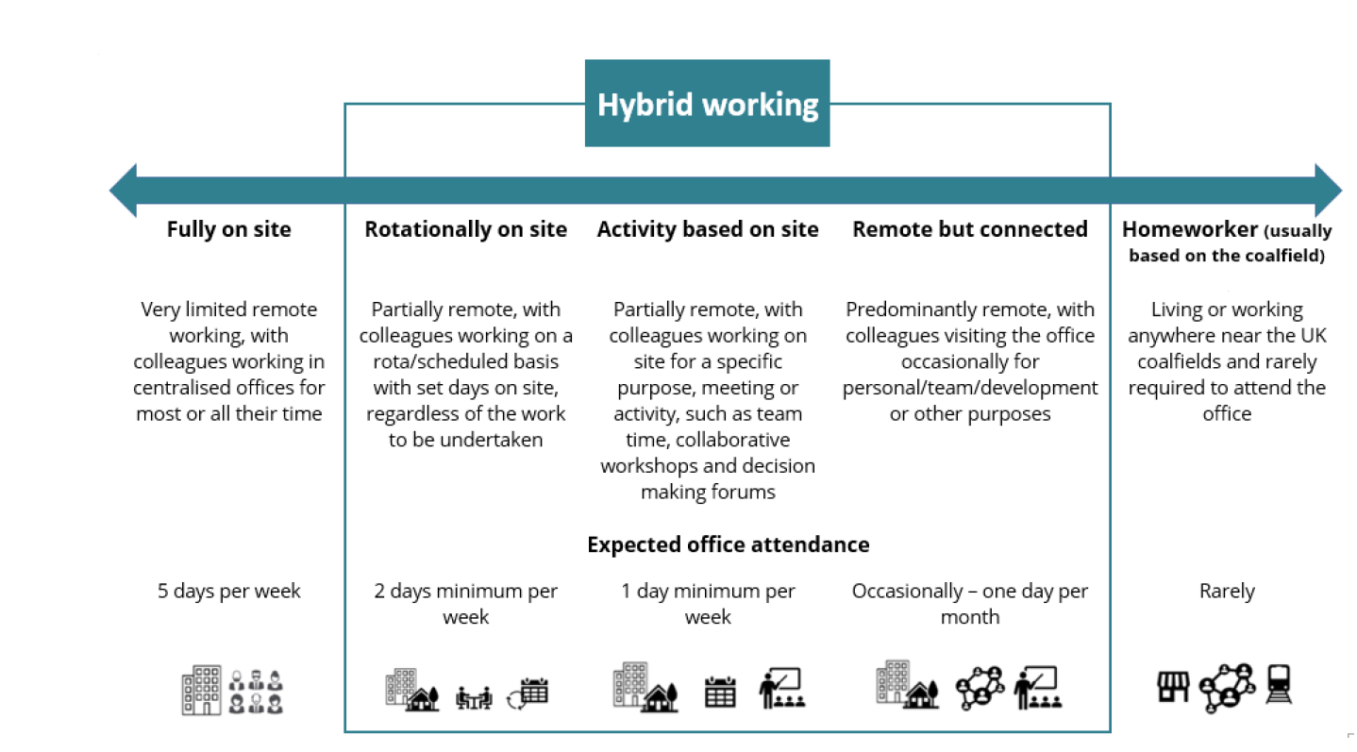

Person specification

Job Title: | Finance Assistant |  | Department: |  | Finance
 | Essential |  | Desirable
Qualifications and Training | - GCSEs (or equivalent) at Grade C or above in Maths & English. |  | - A Level (or equivalent) in relevant subjects.
Experience and Knowledge | - Previous experience of working in a finance team, covering similar tasks to the job description. |  | - Principles and concepts of Accountancy / Finance.
Skills and Abilities | - Excellent inter-personal / communication skills.  - Ability to work under pressure, prioritise workload and achieve deadlines.  - Attention to detail and good organisational / planning skills.  - Proficient in the use of IT and systems (including Microsoft Office applications). |  | - Builds and maintains relationships / networks and delivers a quality service.  - Flexible and adaptable to changing priorities and culture of improvement and change.
 |  |  |  | 

