

Job Title: Customer Correspondence Manager
Department: Customer Support and Services
Reports to: Senior Customer Support Manager
Location: Activity based on site
Contract Type: Fixed-term
Direct Reports: Up to 3 (if required)
Grade: CA5

Main purpose of the job
As the customer correspondence manager, you will take the lead on responding positively to enquiries from customers, members of the public, and residents of local communities or Parliamentarians on behalf of their constituents. You will work with the senior customer support manager, customer correspondence officer and colleagues across the a number of departments to manage and coordinate information relevant to the enquiry, ensuring consistency in the explanation of often complex ideas and technical issues - presenting responses simply and in alignment with the Mining Remediation Authority’s tone of voice.

Responsibilities
- You thrive in high pressured environments with enthusiasm and have the proactive drive to understand complex and often technical information, whilst maintaining a high level of attention to detail.
- Management of the correspondence process to ensure responses to enquiries received are produced to a high standard and in a timely manner.
- You will collaborate with the senior customer support manager, customer correspondence officer and colleagues across the Mining Remediation Authority to gather the necessary information to produce accurate and detailed written responses
- You will produce correspondence on behalf of the Executive Leadership Team and CEO.
- You will support with proactive MP, MSP, MS and elected representative correspondence to maintain strong relationships.
- You will utilise the communication opportunity to provide insight into the work the Mining Remediation Authority does when responding to parliamentarians.
- You will liaise directly with customers over the telephone to help resolve their queries, providing reassurance where required and follow up agreed outcomes and actions in writing.
- Establish and maintain relationships with internal departments and other government departments and local authorities to make sure replies to correspondence are accurate and replied to within the agreed deadline.
- You will support the delivery of complaint responses and ensure a fair outcome has been achieved while providing an exceptional level of customer service in accordance with our customer standards and tone.
- You will maintain and upkeep a record of correspondence on the Mining Remediation Authority’s internal customer systems, as well as troubleshooting queries and identifying improvements.
- You will act with discretion and maintain confidentiality of correspondence.
- You will produce documents to a high standard using the appropriate software, including the following but not limited to; MS Office and Excel.

General
- To act in accordance with the behaviours and values of the organisation
- To manage your own performance to be accountable for meeting individual, team and corporate objectives
- To act in accordance with the Scheme of Delegation and ensure propriety and regularity in the handling of public funds
- To comply with and contribute to the improvement of operational and team processes and procedures
- To assist with the preparation and execution of the team’s objectives, budgets and financial records
- To identify opportunities and implement change leading to team development, system improvement and good value for money
- To maintain and develop positive stakeholder relationships in order to promote the Authority and assist it to meet its objectives
- To support research and development projects
- To ensure that the Authority’s statutory responsibilities are effectively discharged
- To carry out any further reasonable requests from your line manager

Values in Action
We expect all our colleagues to embody our core values and behaviours in their daily work.

Trusted
- We act with integrity
- We’re open and transparent
- We deliver on our commitments
Inclusive
- We promote a culture of mutual respect
- We recognise that our differences make us stronger
- We work with others to achieve our vision
Progressive
- We’re open minded and innovative
- We recognise that the past can help us shape the future
- We listen and learn

Our Values in Action framework outlines important behavioural indicators which help us demonstrate our values through our work together.

Hybrid Working Model
This role sits within our Hybrid Working Model. The designated hybrid arrangement for this post is outlined under “Location” on page 1 of this Job Description and reflects the requirements of the role and the organisation. Hybrid working arrangements may be reviewed and adjusted if business needs change.
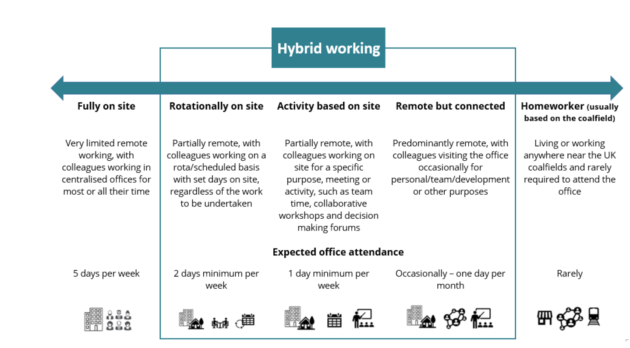

Person specification

Job Title: Customer Correspondence Manager

Section/Department: Customer Support and Services
 | Essential | Desirable
Qualifications and Training | - GCSEs grades A – C (to include English & Maths).  - Proficiency in MS Office systems  - Excellent written English and communication skills | - Excel proficient  - Knowledge of accessibility regulations WCAG2.1
Experience and Knowledge | - Demonstrable experience of liaising and coordinating with key stakeholders across a wide range of organisations  - 2-5 years in a customer service environment  - Experience of managing or supervising staff  - Experience of dealing with a wide range of correspondence varying in complexity | - Operational background /understanding of operational organisation  - Experience of working with parliamentarians  - Experience of dealing with written complaints/ dissatisfaction  - Experience of working with local communities  - Knowledge of GDPR, Data protection
Skills and Abilities | - Excellent time management skills and ability to multi-task and prioritise work.  - Ability to work to tight deadlines.  - Maintain confidentiality.  - Attention to detail and problem solving skills.  - Exemplary written English and communication skills  - Emotionally intelligent, with an understanding and concern for others, with the ability to sometimes take a neutral view of emotive and distressing issues  - Ability to use positive language  - Ability to demonstrate patience  - Ability to work under pressure  - Flexibility to adapt quickly in response to change | - Multi agency emergency response experience
Other | - Flexibility to meet the requirements of the job.

