Job Title: | Assistant Hydrologist
Department: | Environment
Reports to: | Hydrology Team Lead (Senior Hydrologist)
Direct Reports: | None
Location: | Activity Based on Site
Contract Type: | Permanent
Grade: | CA4

Main purpose of the job

- To assist in the provision of hydrological and hydrometric services to support and advise the Mining Remediation Authority’s operational activities, and its strategic mine water programmes.
- To assist the Mining Remediation Authority’s other hydrologists in performing their
duties.

Responsibilities

Specific
- Support the delivery of hydrological and hydrometric services, including the design, delivery and oversight of flow monitoring surveys.
- Analyse and appraise flow monitoring data, identify data quality issues and recommend solutions.
- Assist in the specification, installation and maintenance of flow monitoring structures and instrumentation, ensuring an appropriate balance of time, cost and quality, and clear communication of monitoring requirements and project risks.
- Develop knowledge of relevant standards (e.g. BS ISO, MCERTS), monitoring techniques and equipment, and contribute to future monitoring strategies.
- Investigate flow monitoring issues and support the implementation of solutions by contractors.

- To contribute to the development of the environmental data management system (AQUARIUS) to store, assess, edit, grade and graphically present monitoring data, with an emphasis on continual improvement of quality and timeliness of data entry and processing of that data.
- Provide hydrological advice to support strategic mine water programmes and ensure appropriate monitoring data is collected and interpreted.
- Produce or contribute to technical reports, papers and presentations relating to hydrology and hydrometry.
- Undertake site inspections, flow surveys and the installation, maintenance and checking of datalogging and monitoring equipment.
- Assist with the management of hydrological equipment and support the training and supervision of others in its safe use.
- Deputise for Hydrologists as required.
- Support mine water, flood risk and catchment-scale projects, including source apportionment, water quality analysis and liaison with regulators.
- Assist in providing hydrological input to mine water treatment scheme design.
- Support hydrogeological work as opportunities arise.

General
- Act in line with the behaviours and values of the organisation.
- Manage your own performance to be accountable for meeting individual, team and corporate objectives.
- Act in accordance with the Scheme of Delegation and ensure propriety and regularity in the handling of public funds.
- Actively demonstrate the Mining Remediation Authority’s customer service standards expected of your role.
- Follow and contribute to the improvement of operational and team processes and procedures.
- Assist with the preparation and delivery of the team’s objectives, budgets and financial records.
- Identify opportunities and implement change leading to team development, system. improvement and ensuring good value for money.
- Maintain and develop positive stakeholder relationships in order to promote the Authority and assist it to meet its objectives.
- Support research and development projects.
- Ensure that the Authority’s statutory responsibilities are effectively discharged.
- Carry out any further reasonable requests from your line manager.

Values in Action
We expect all our colleagues to embody our core values and behaviours in their daily work.
Trusted
- We act with integrity
- We’re open and transparent
- We deliver on our commitments
Inclusive
- We promote a culture of mutual respect
- We recognise that our differences make us stronger
- We work with others to achieve our vision
Progressive
- We’re open minded and innovative
- We recognise that the past can help us shape the future
- We listen and learn
Our Values in Action framework outlines important behavioural indicators which help us demonstrate our values through our work together.
Hybrid Working Model
This role sits within our Hybrid Working Model. The designated hybrid arrangement for this post is outlined under “Location” on page 1 of this Job Description and reflects the requirements of the role and the organisation. Hybrid working arrangements may be reviewed and adjusted if business needs change.
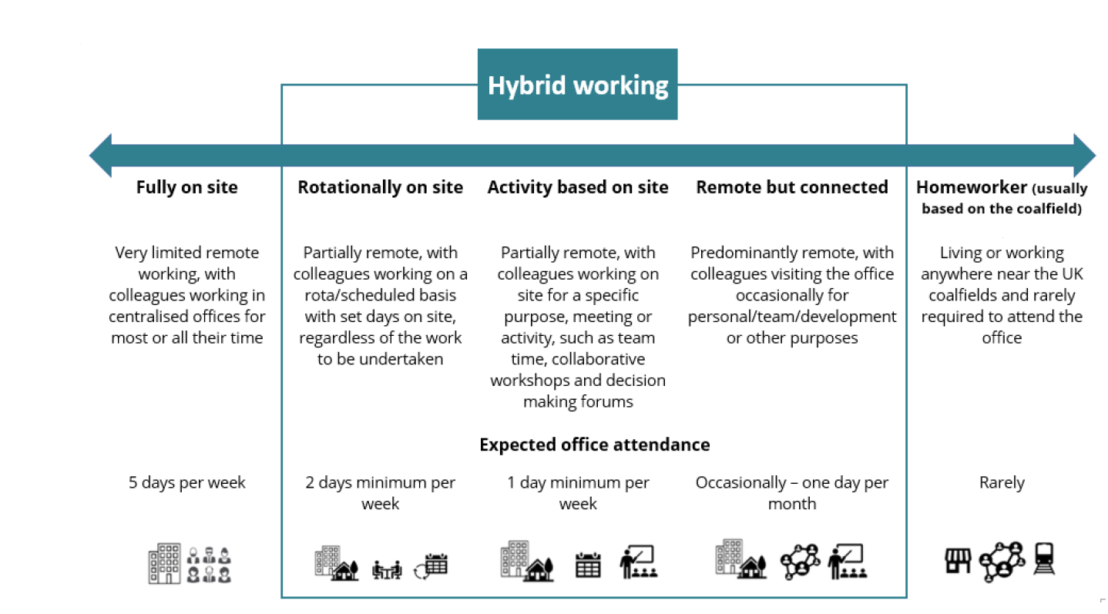

Person specification

Job Title: | Assistant Hydrologist |  | Department: |  | Technical Services
 | Essential |  | Desirable
Qualifications and Training | - Degree in an Environmental based subject covering elements |  | - MSc Hydrology, or similar higher degree.  - Membership of an appropriate professional body (e.g.  - CIWEM)  - Working towards Chartered Status
Experience and Knowledge | - Practical experience of hydrometry; i.e. measuring flows, and installing structures.  - Practical experience of desk and site based hydrology e.g. review of mapping, working with hydrological datasets, undertaking site walkovers, catchment delineation etc. |  | - Supervision and management of contractors  - Post-graduate experience in practical hydrology / hydrometry  - Water sampling / quality monitoring  - Source Apportionment & Catchment Characterisation  - Experience of GIS systems  - Hydrological modelling e.g. rainfall-runoff, dispersion, hydraulic etc.
Skills and Abilities | - Ability to interpret flow monitoring data.  - Ability to work under pressure Excellent communication and interpersonal skills .  - Excellent written communication and presentation skills Excellent IT skills Report writing skills. |  | - Use of hydrological software packages  - Ability to specify and install water monitoring instrumentation  - Flood Risk Assessment Constructed wetlands
Other | - Frequent travel on business to attend meetings or visit  - monitoring sites, and occasional installation of data loggers.  - Approx. 7-10,000 miles per year.  - Occasional nights away from home, up to two times per month  - Possible future overseas working required  - Full UK Driving Licence
 |  |  |  | 

